explorando hitos a partir de las palabras de los tweets

Wa1dO

9/12/2017

*ESPAÑA*

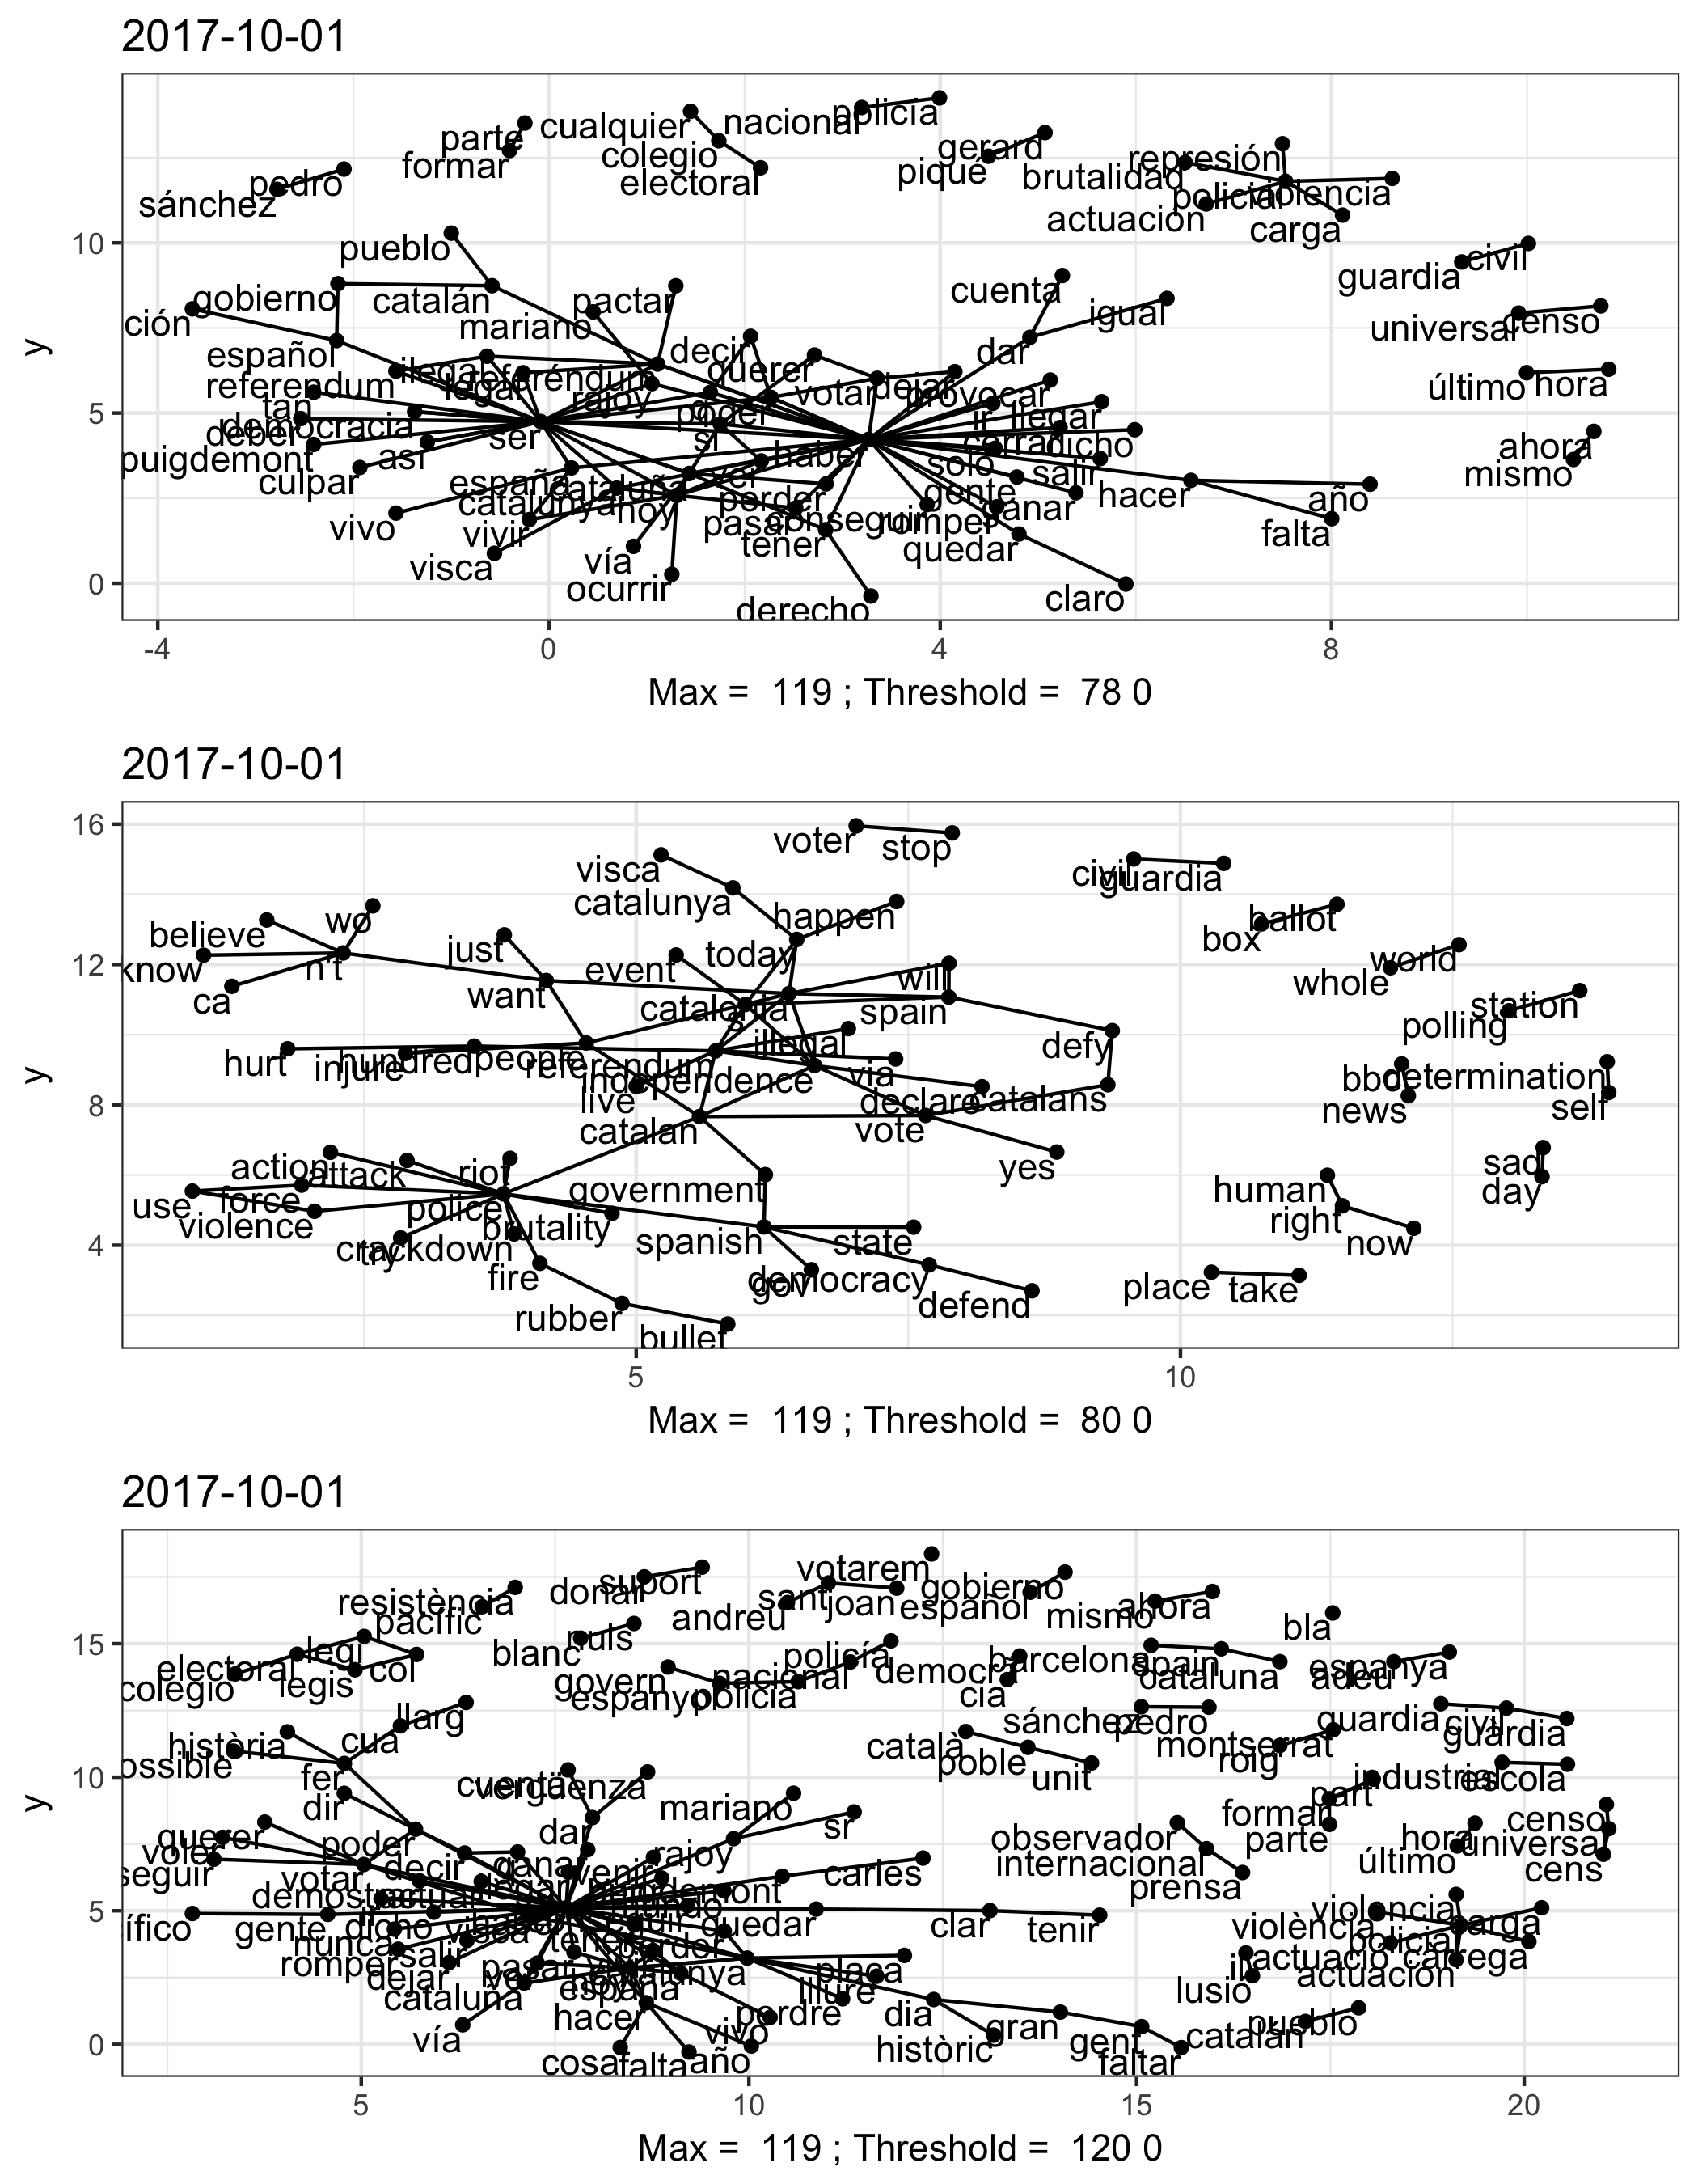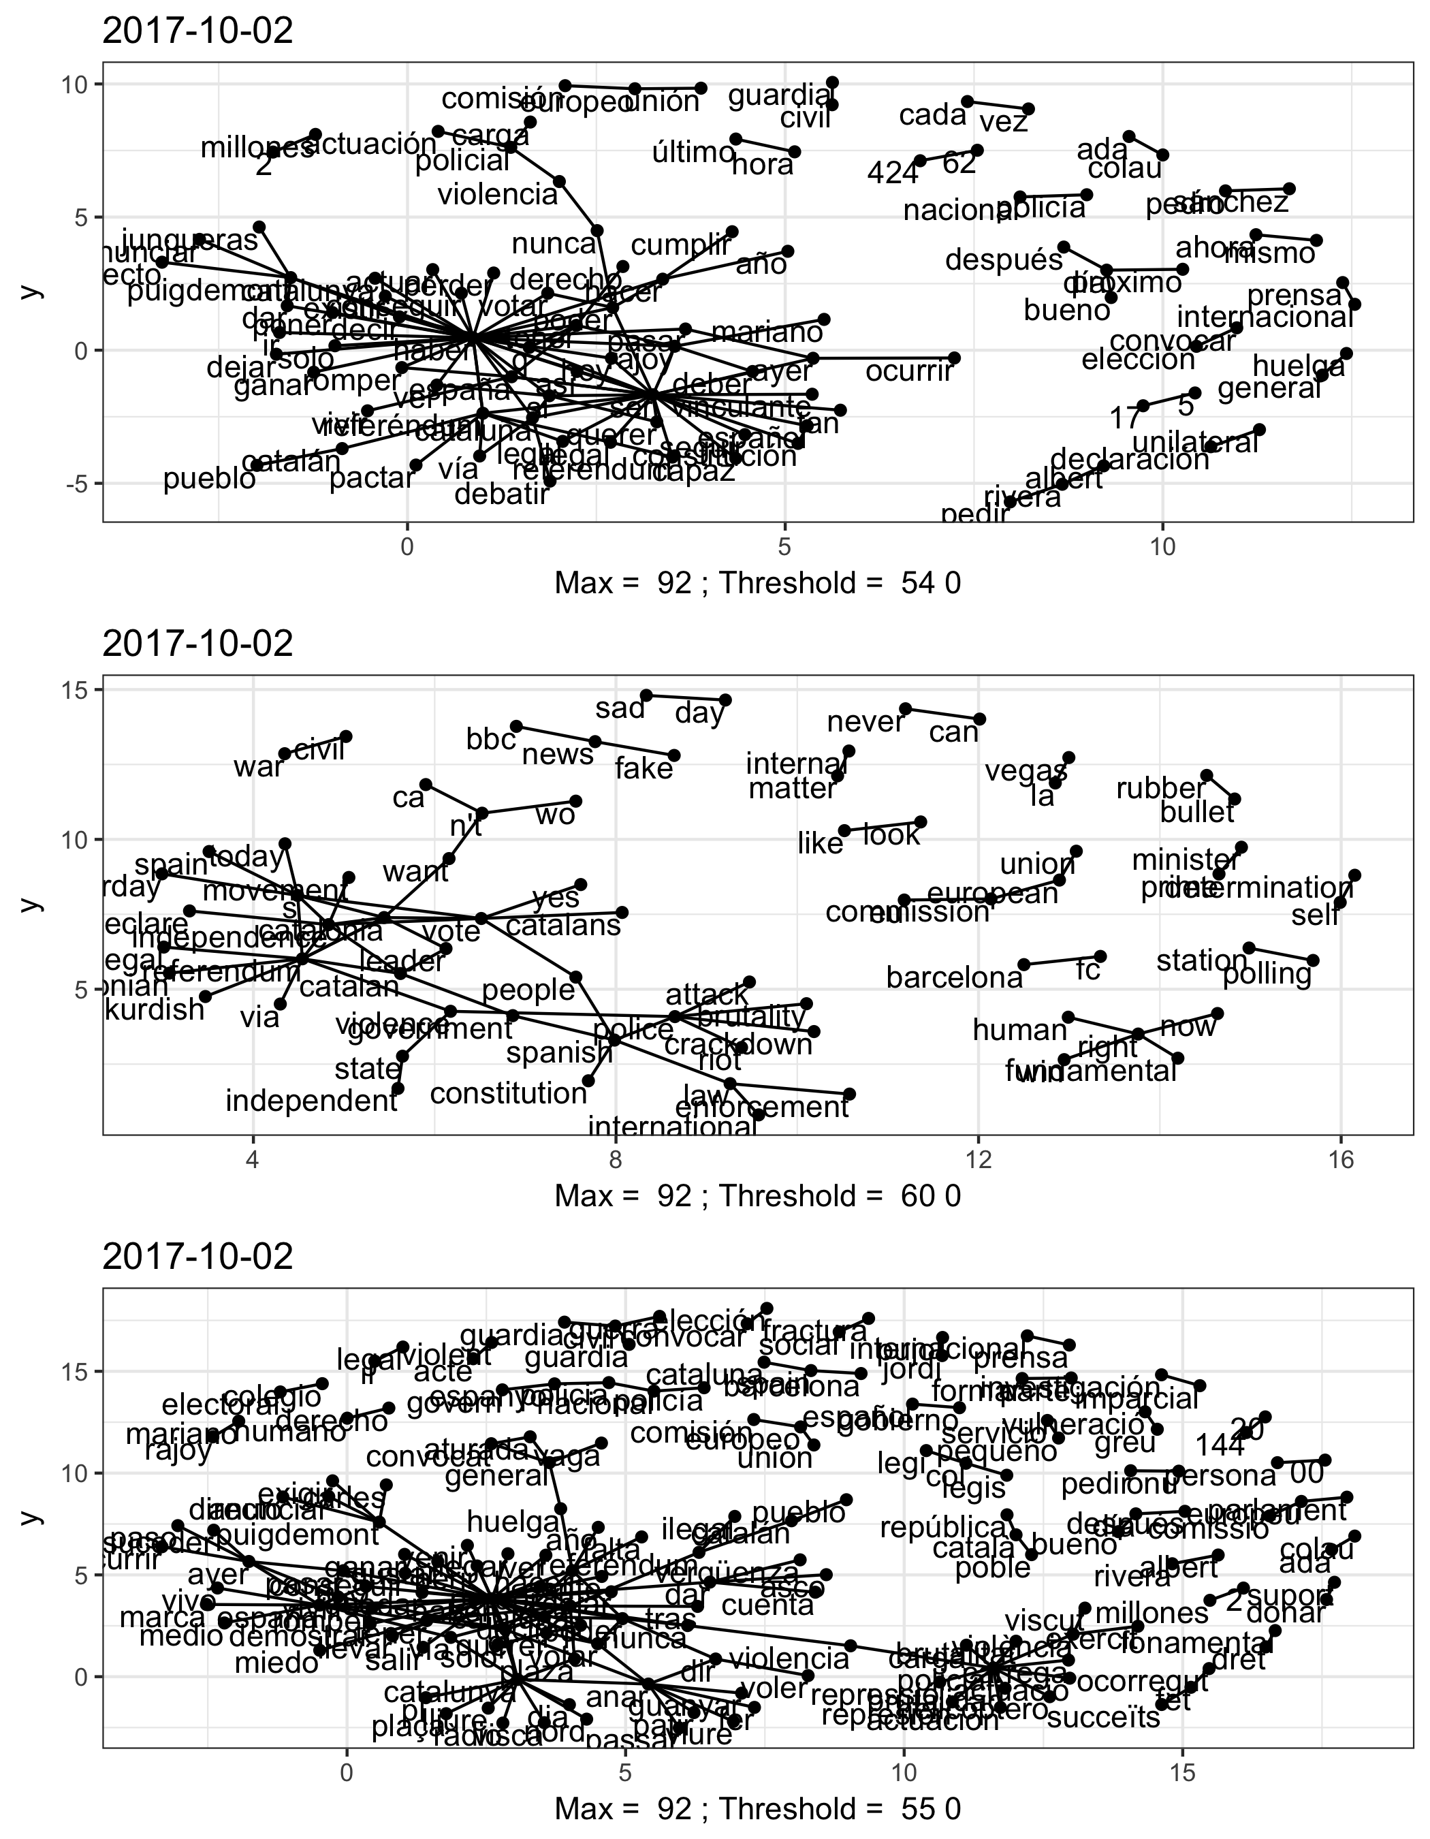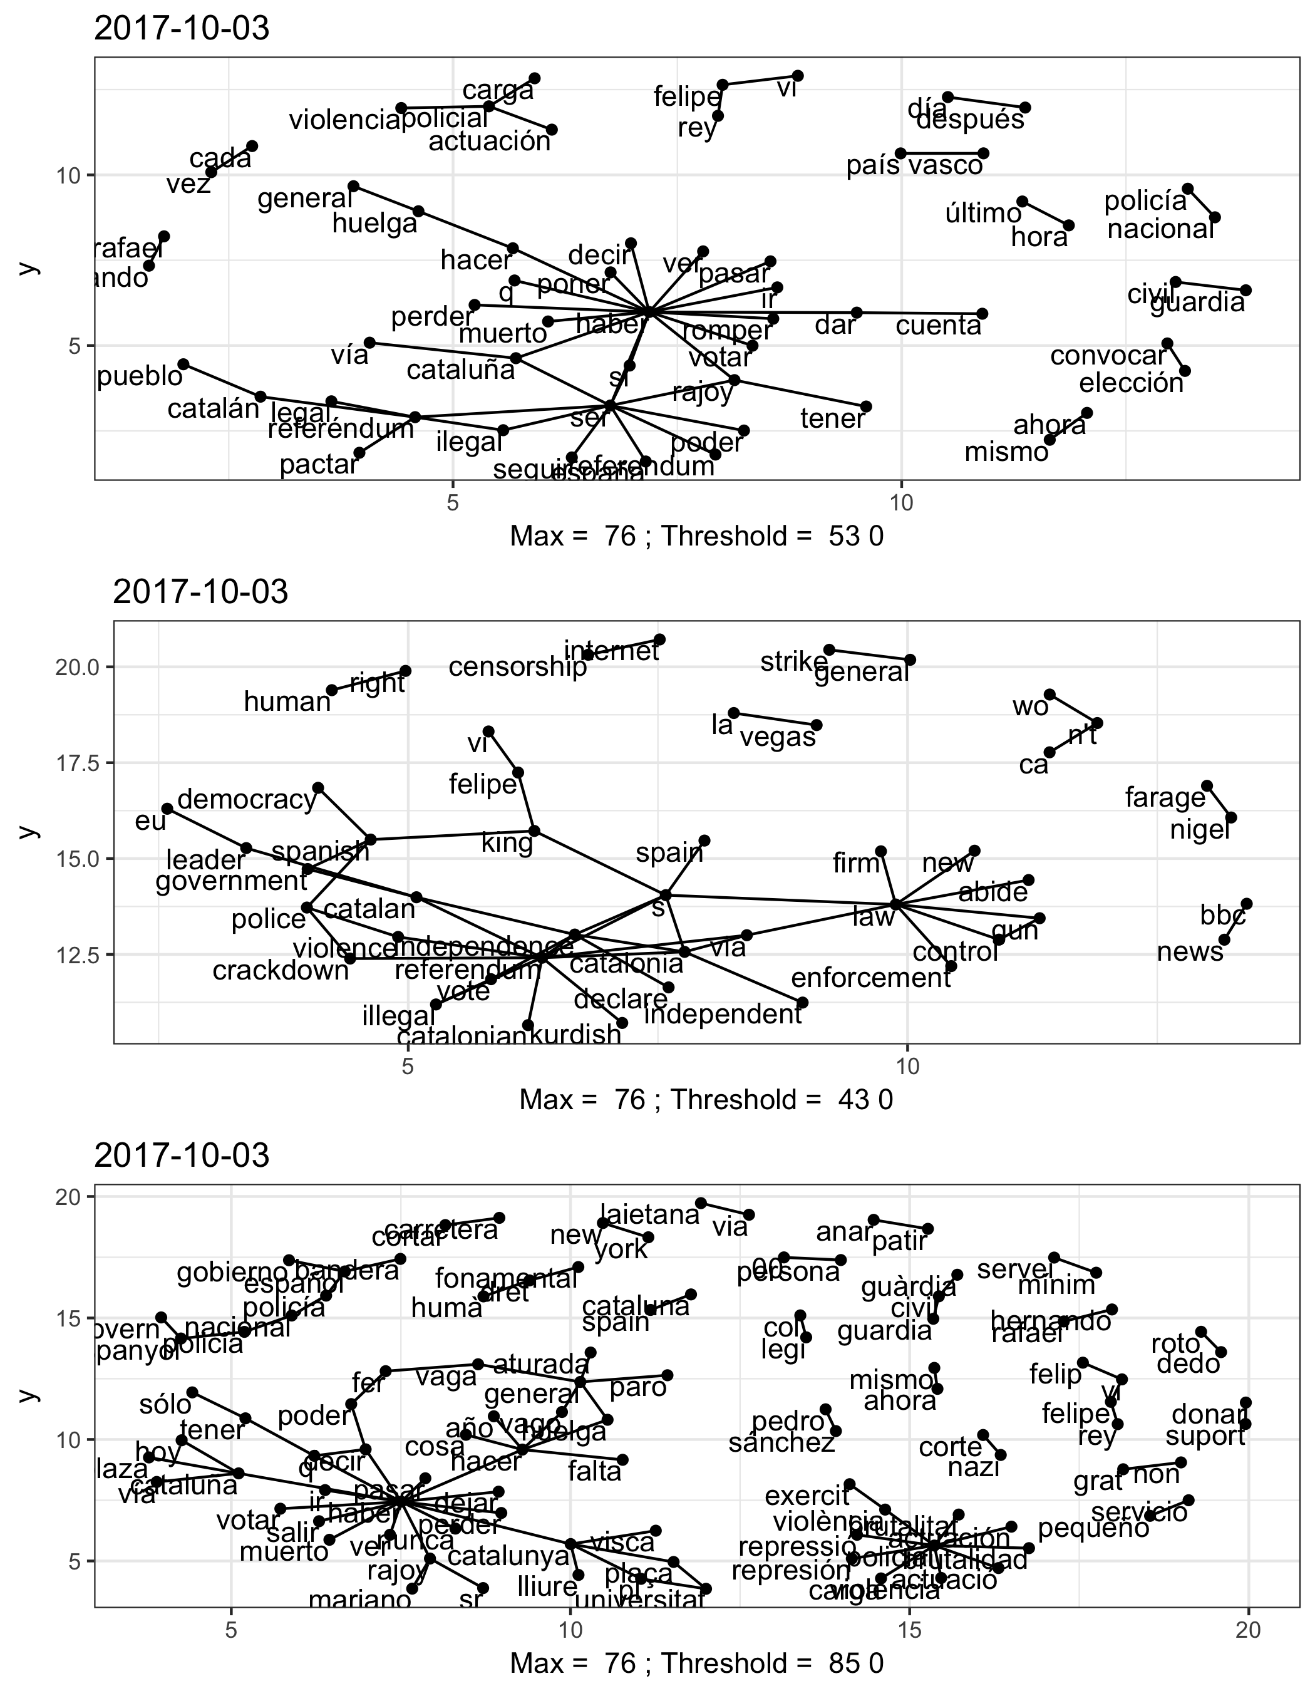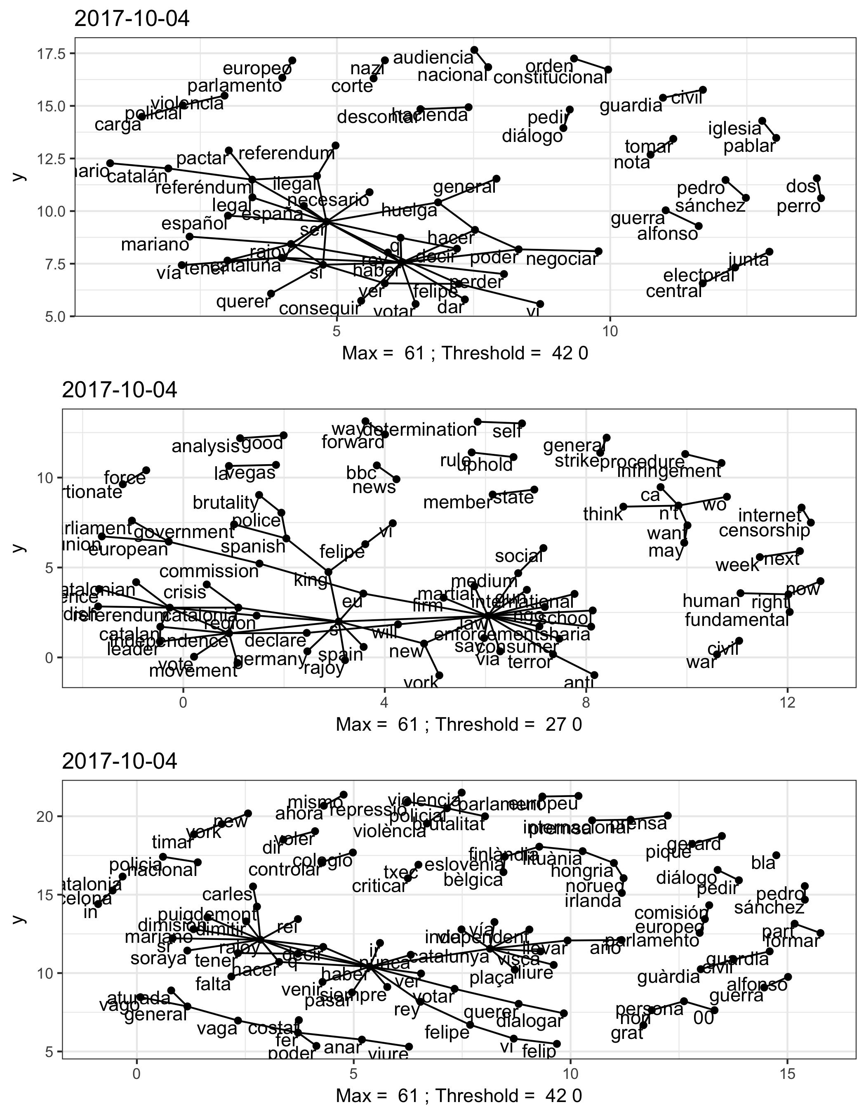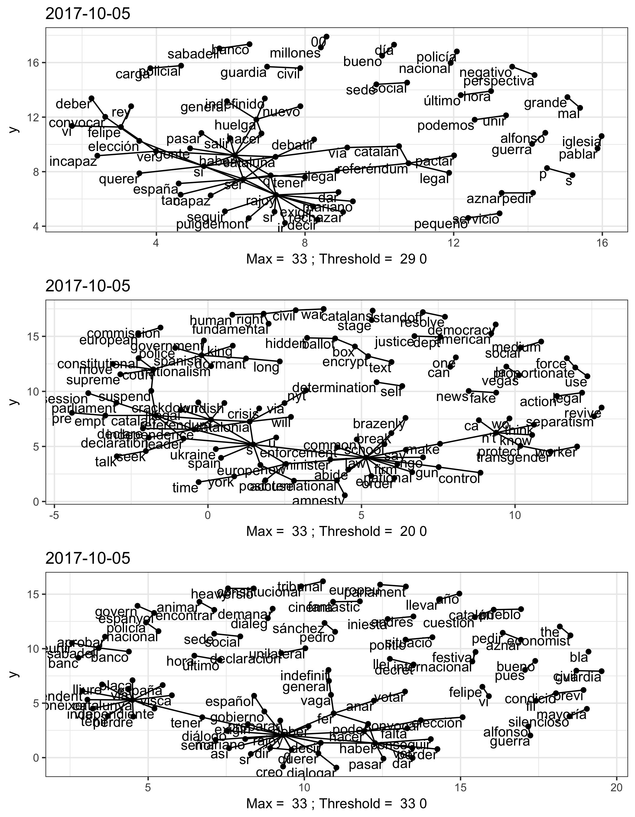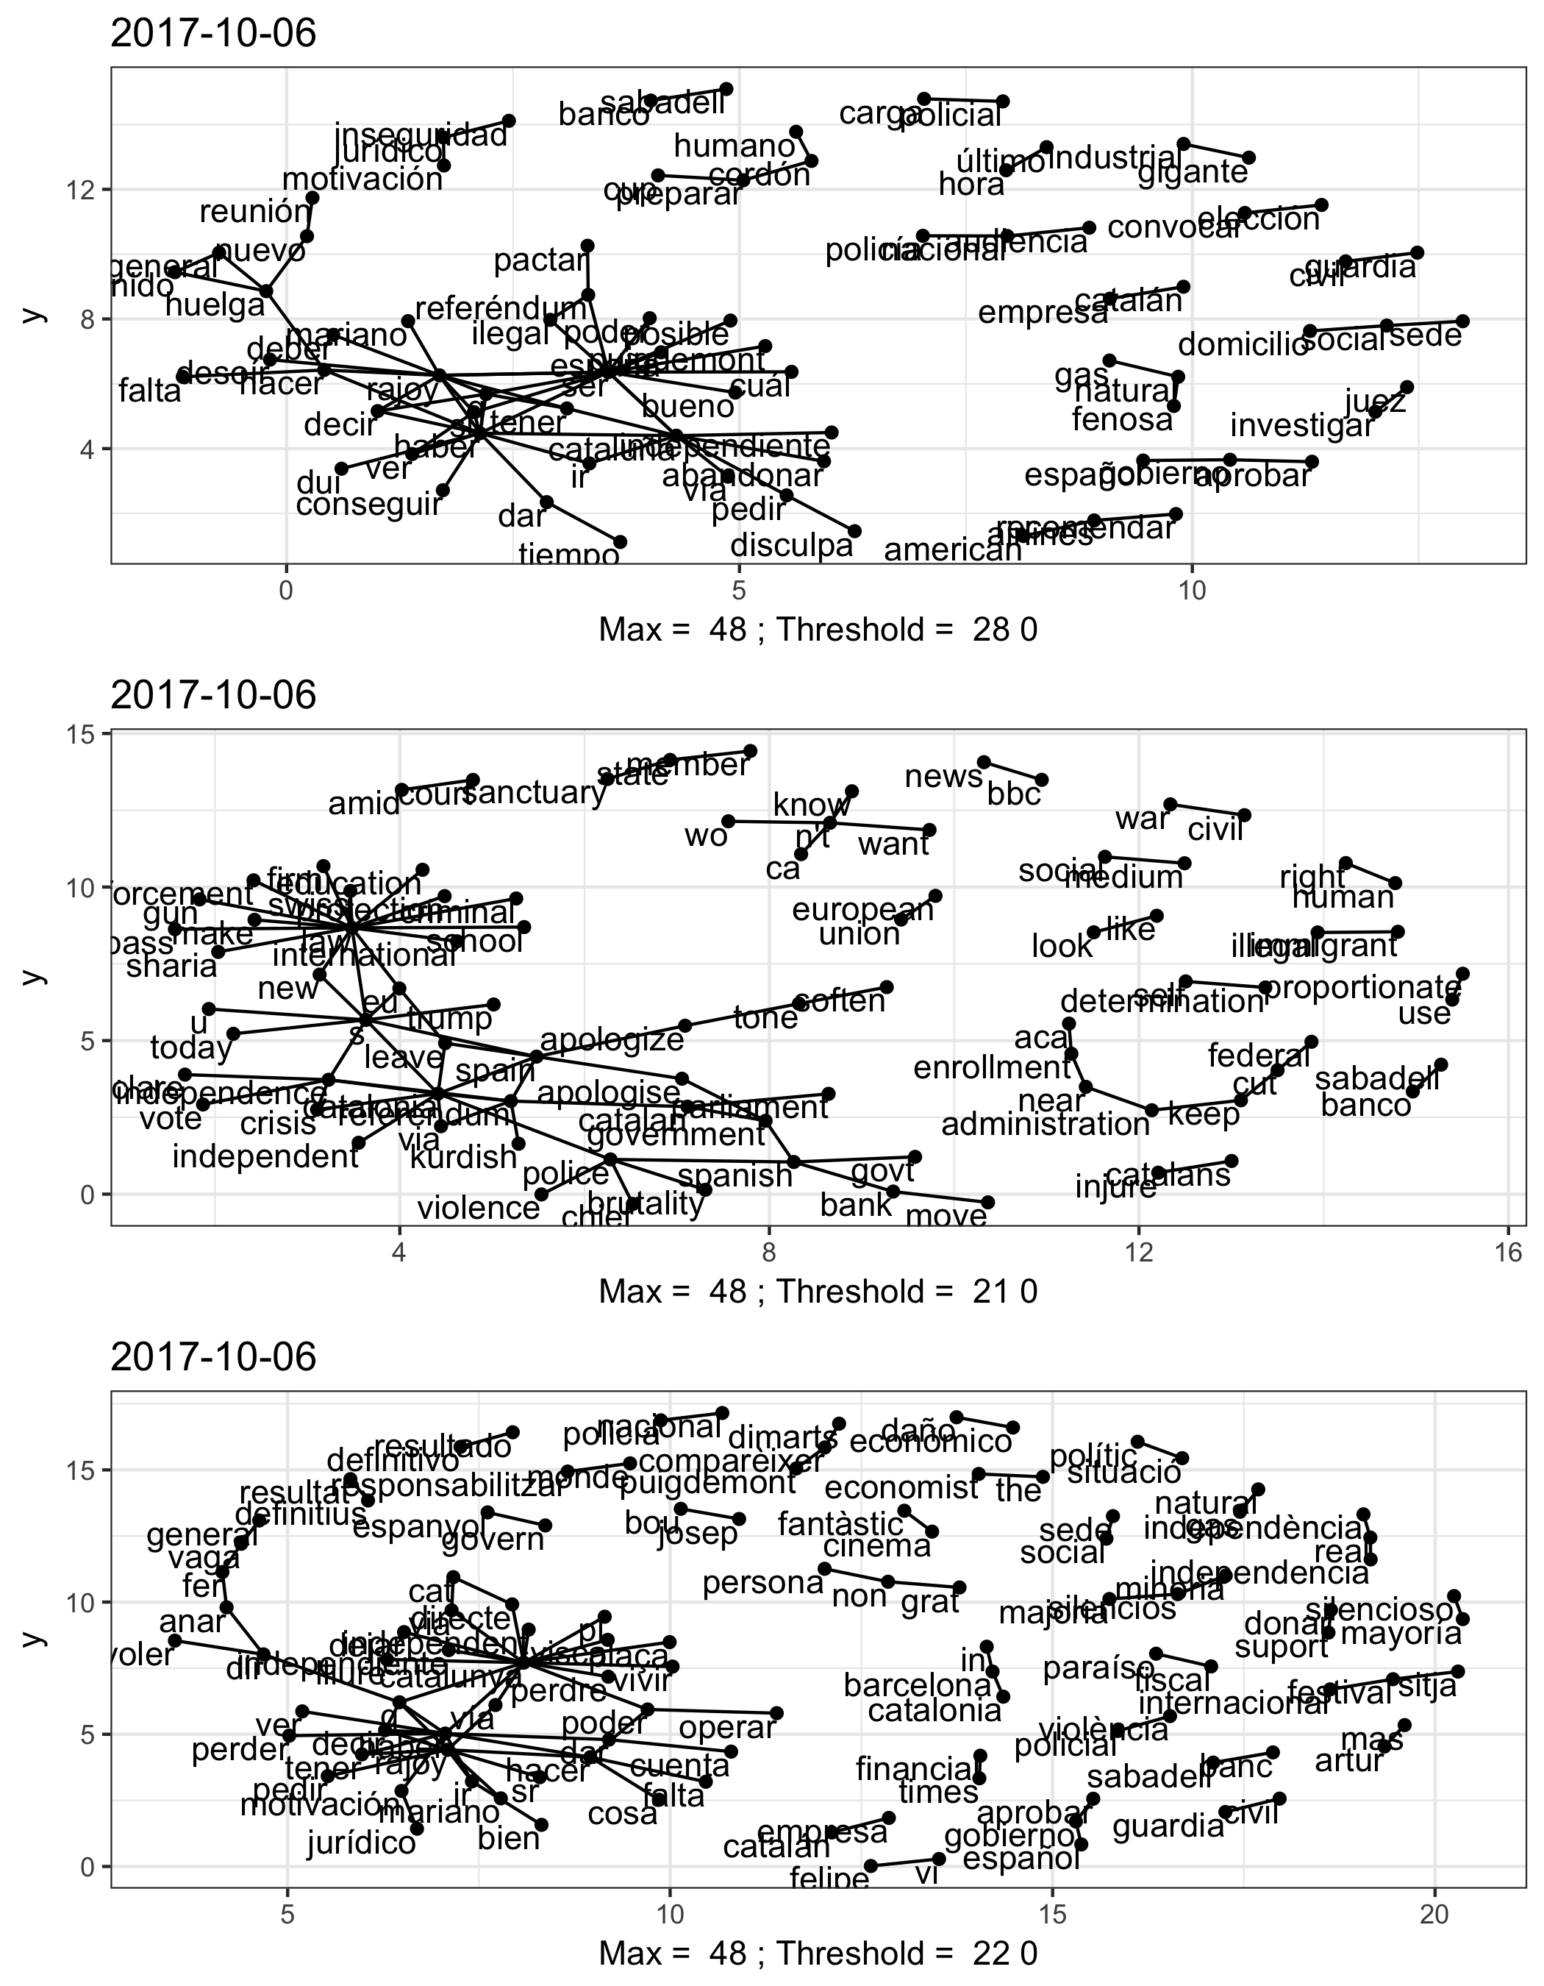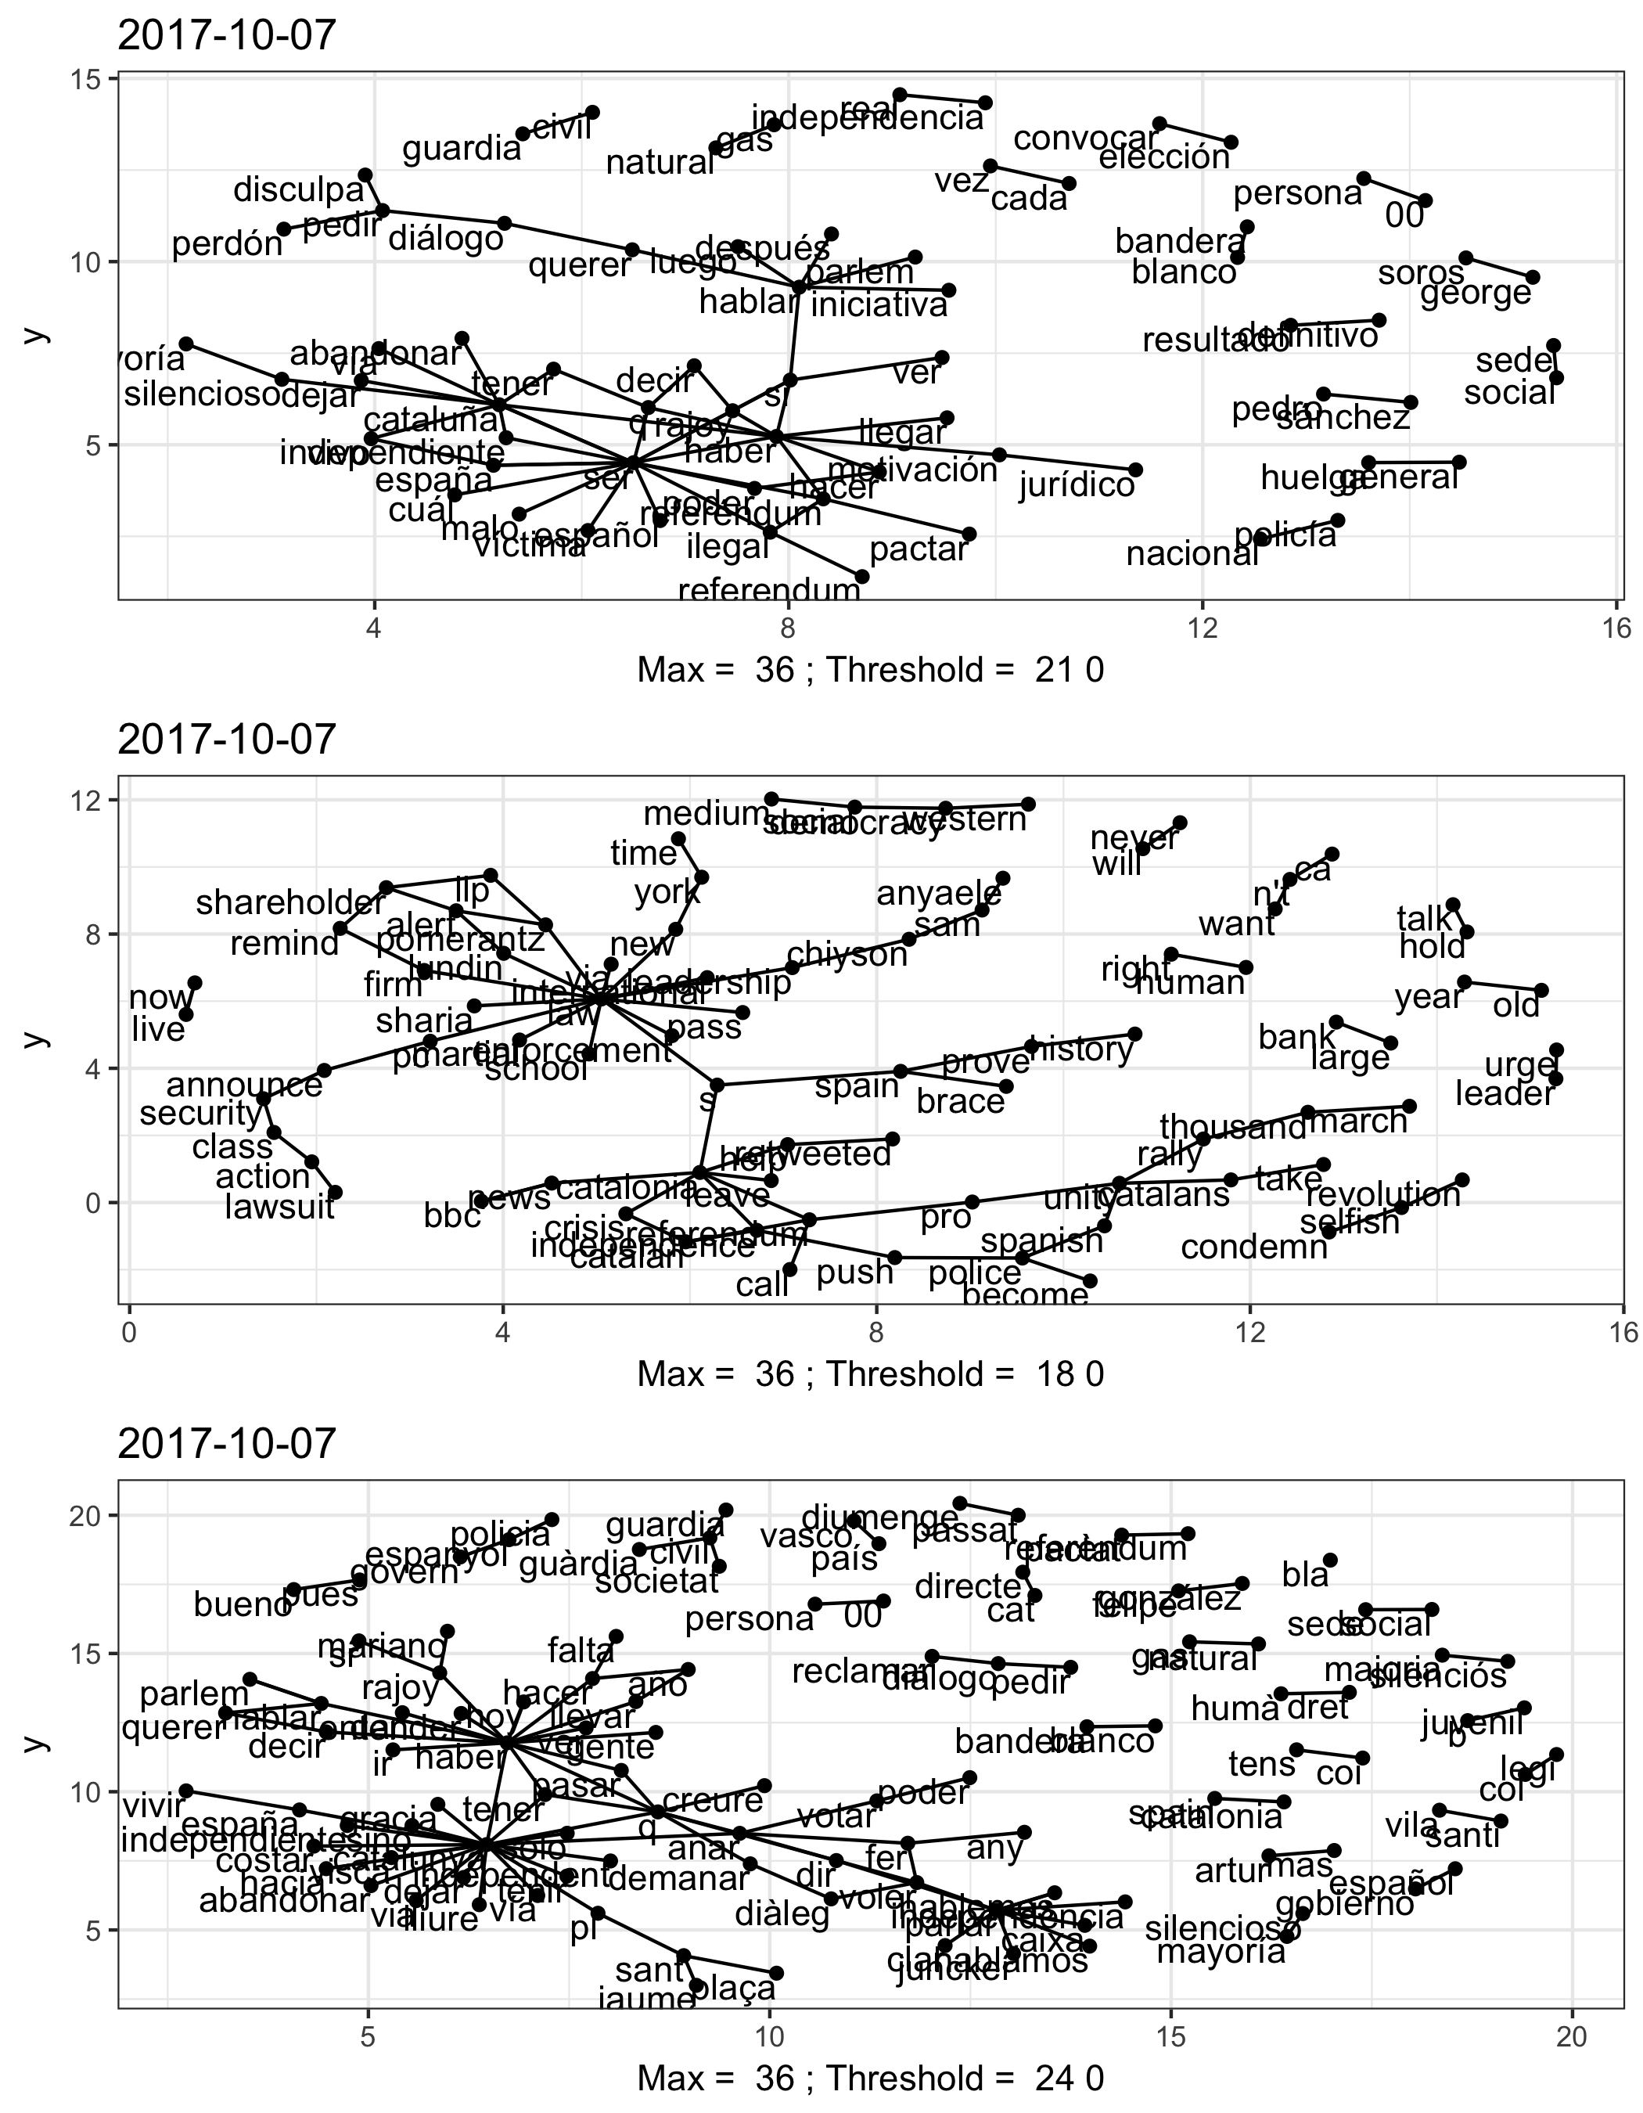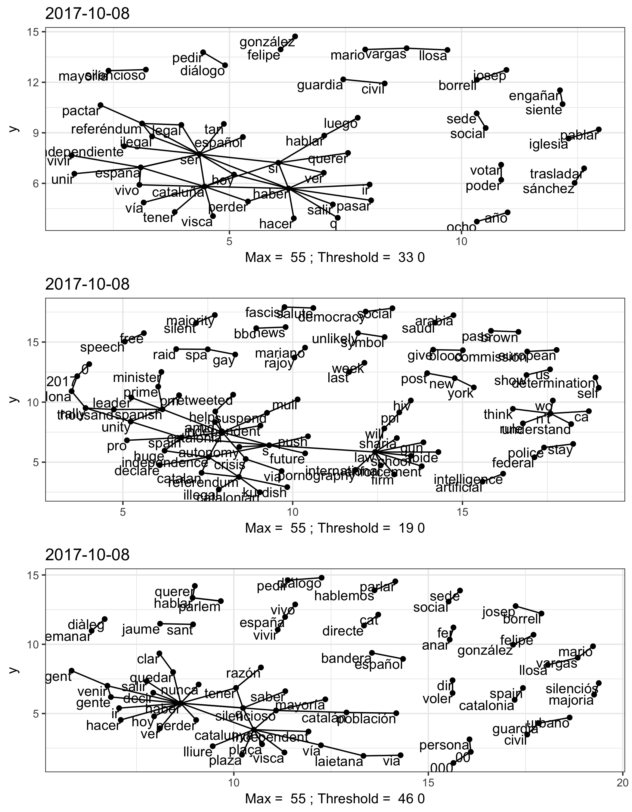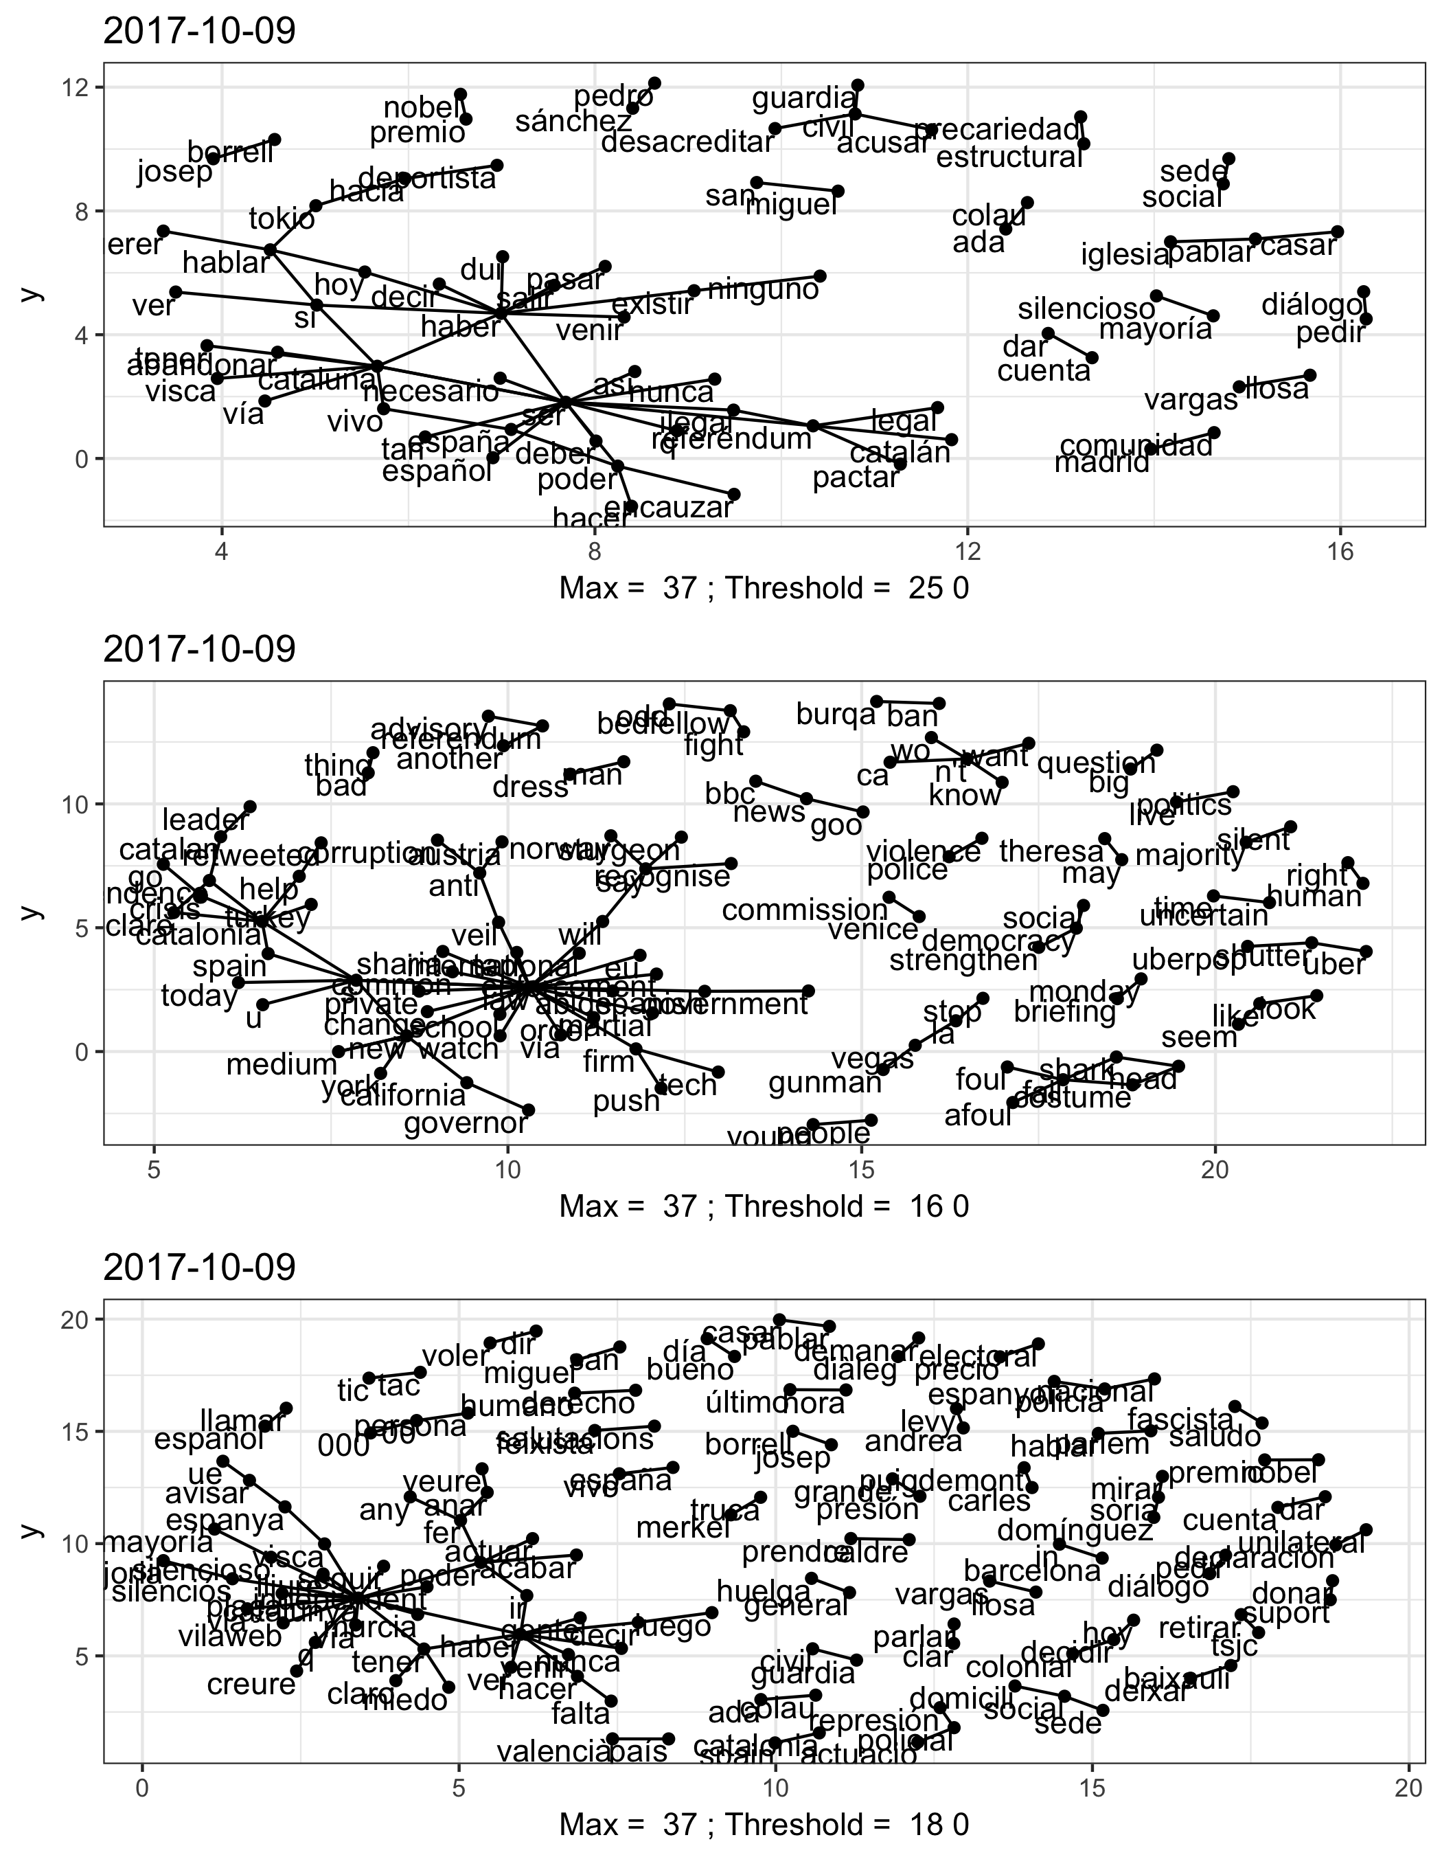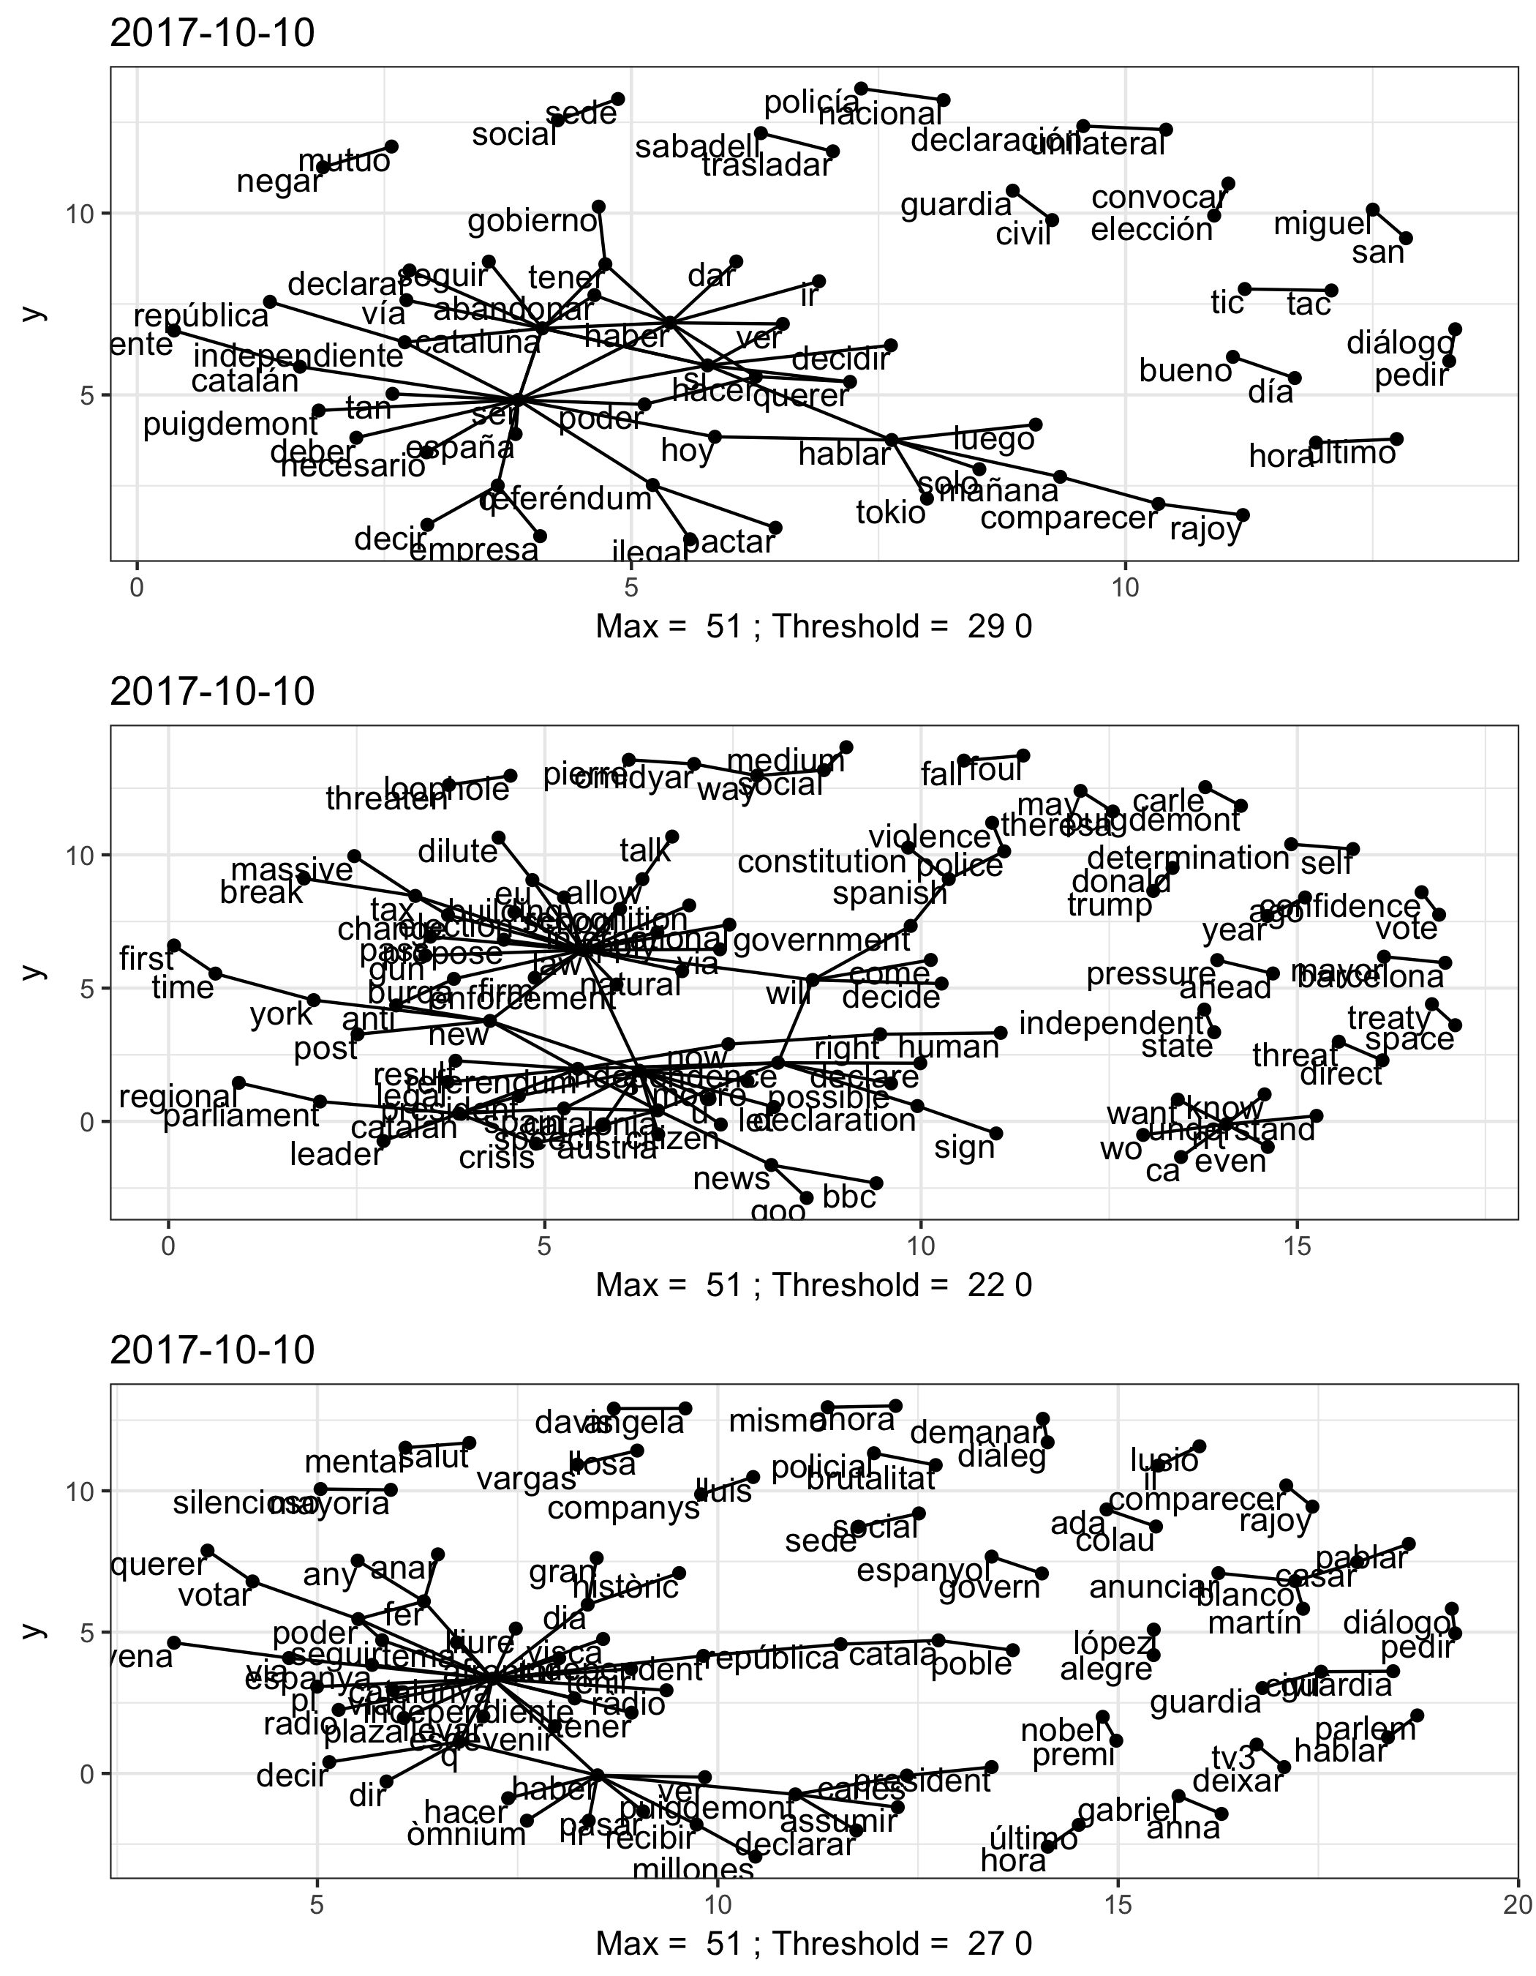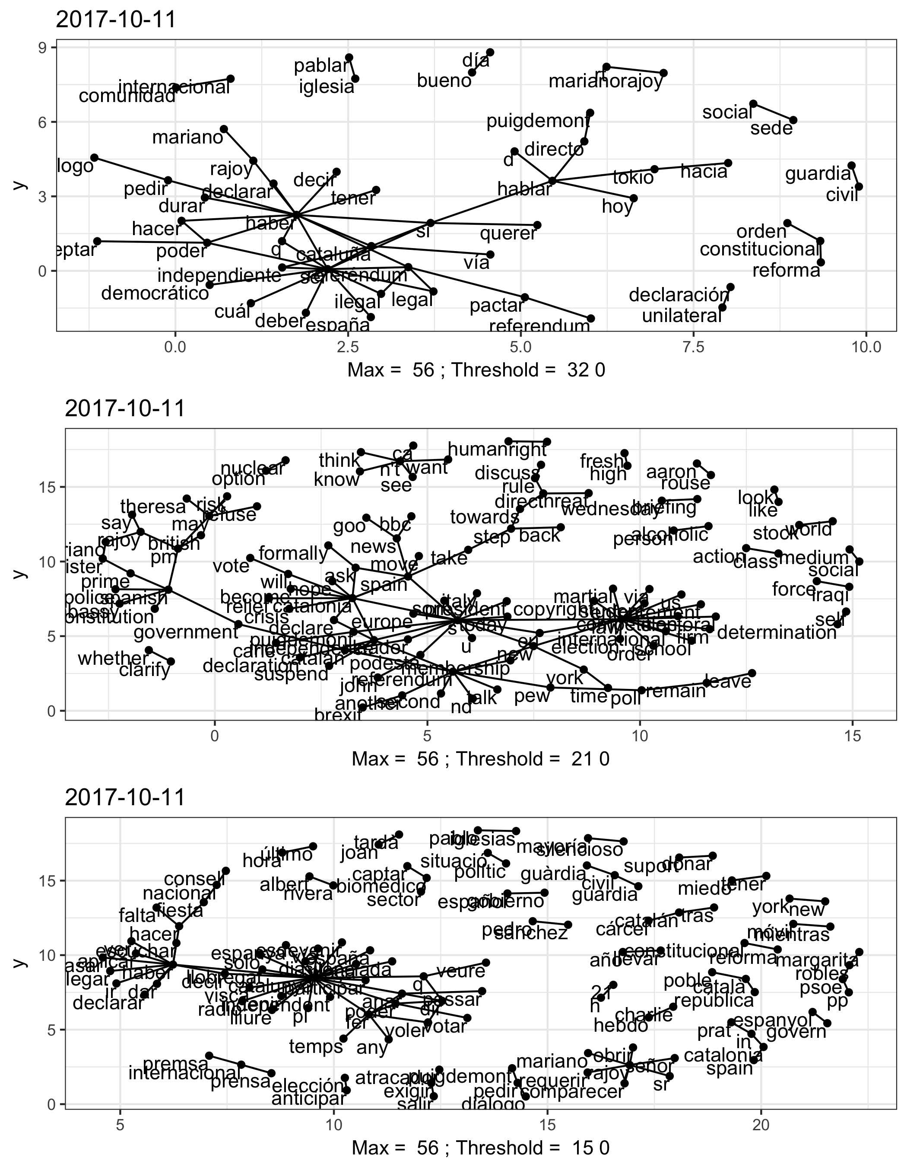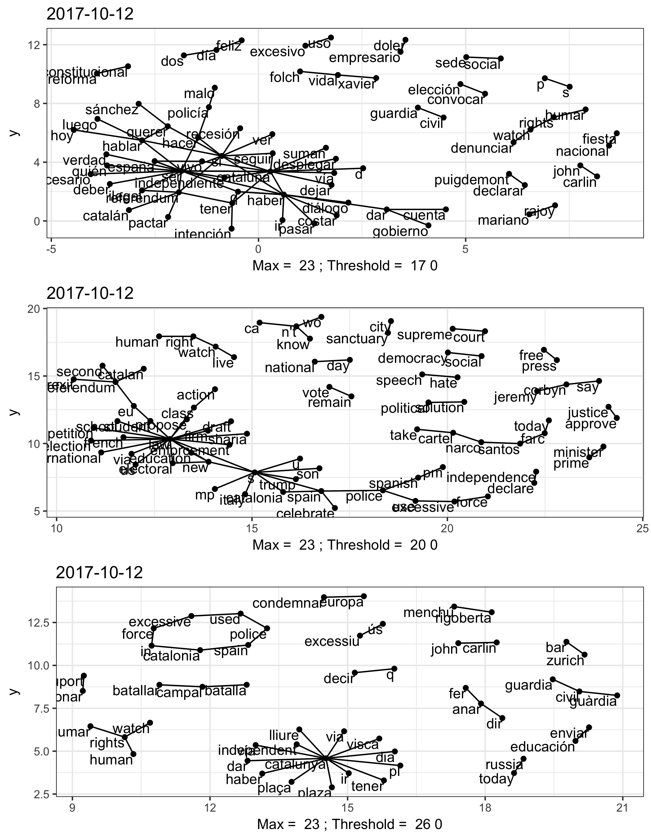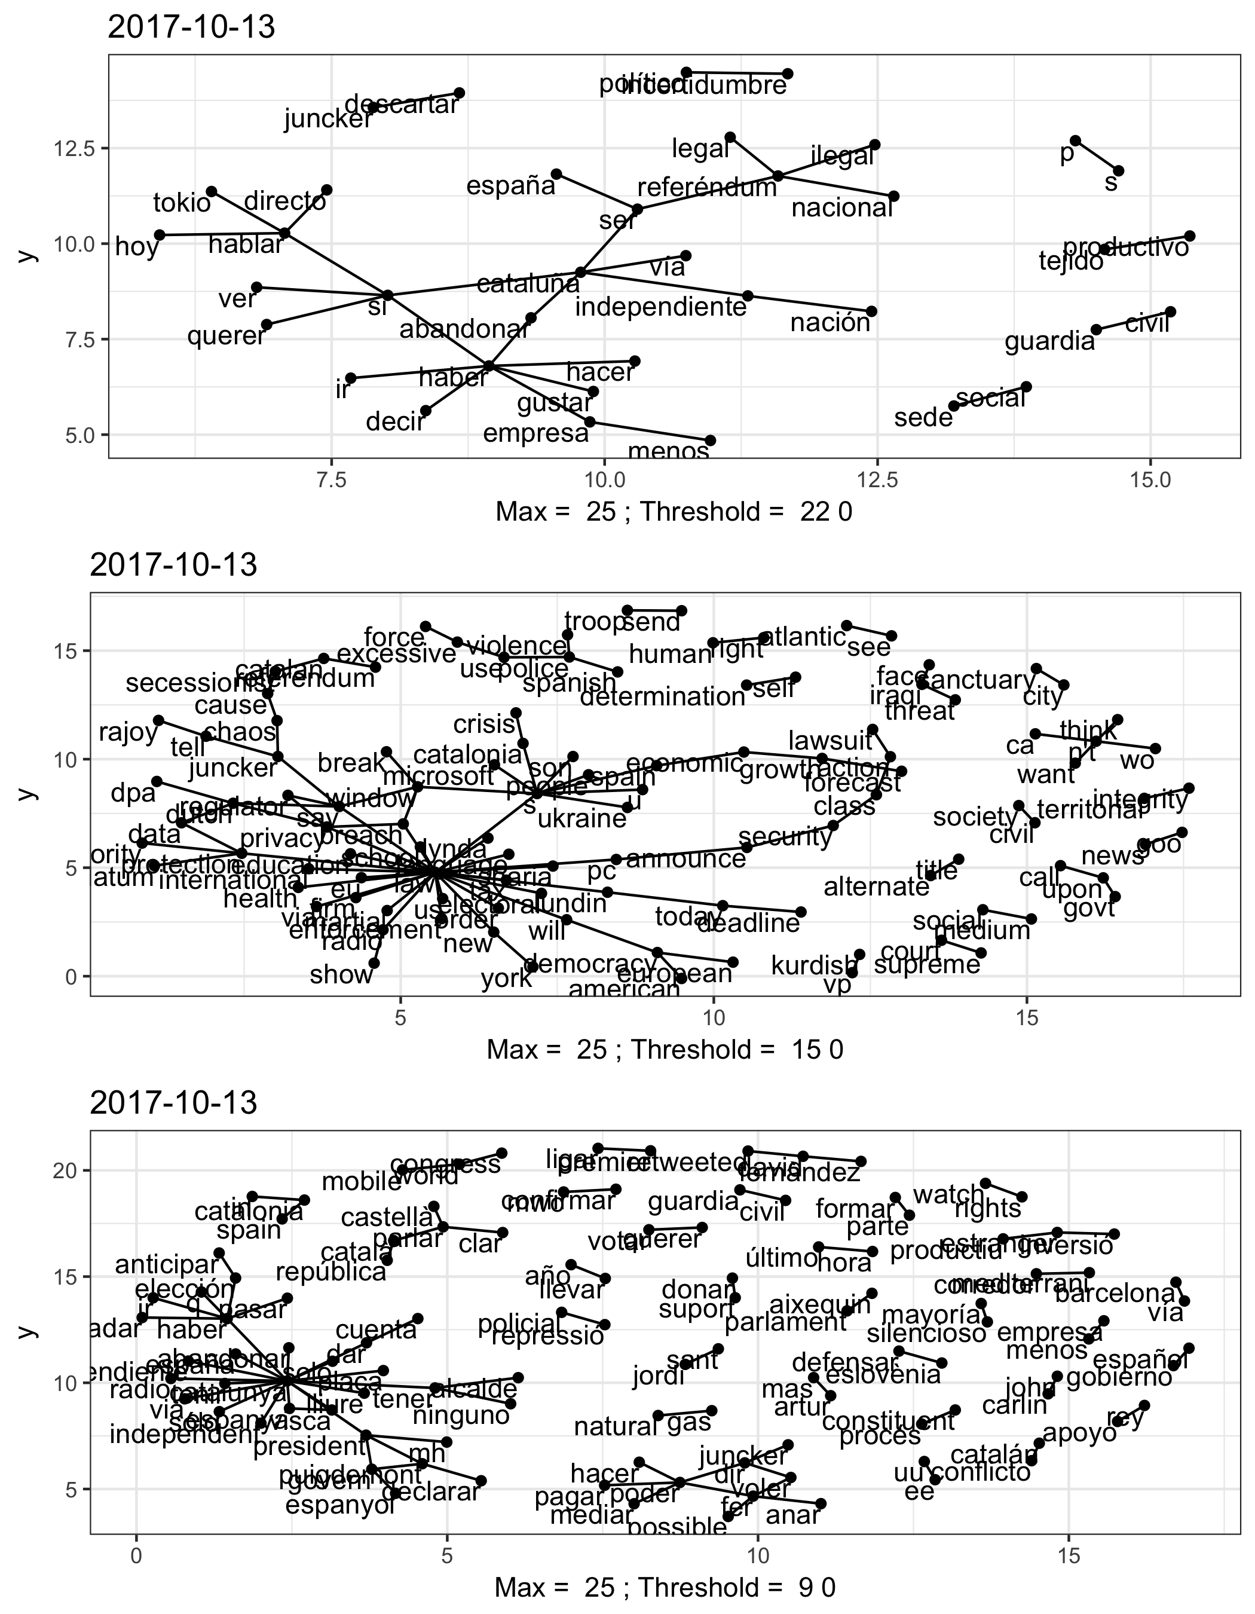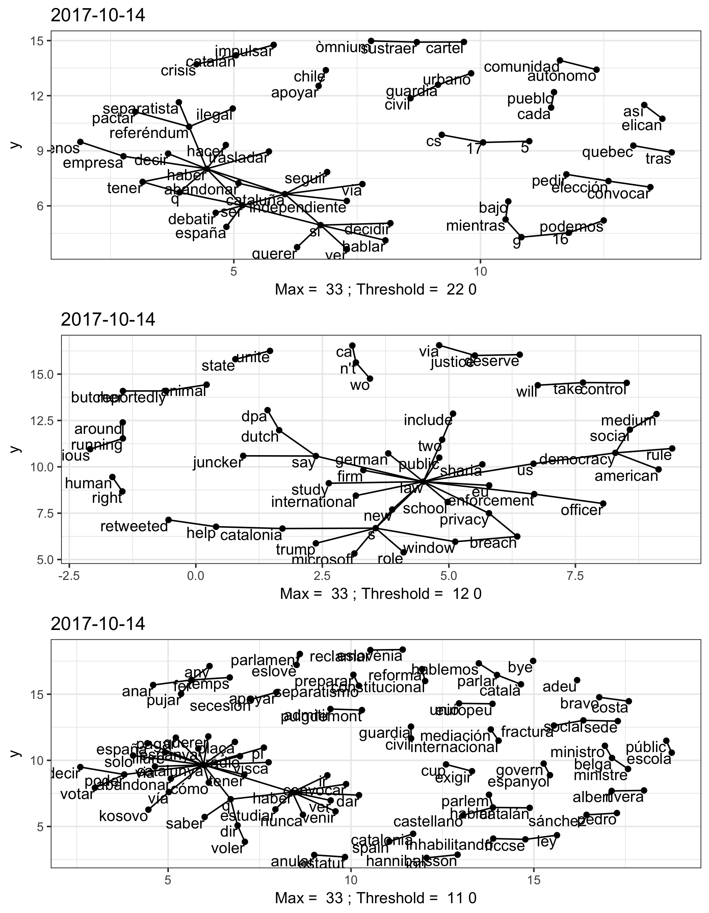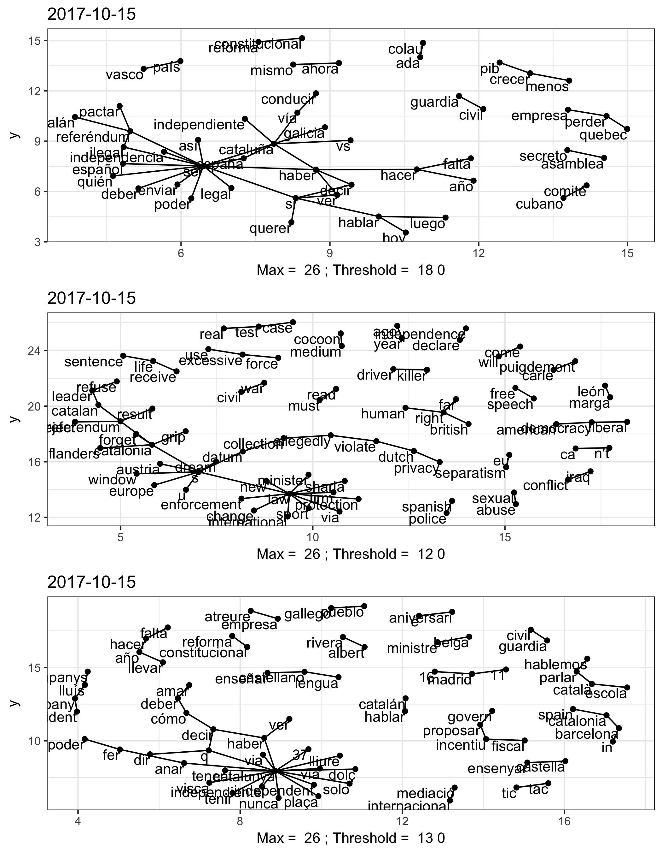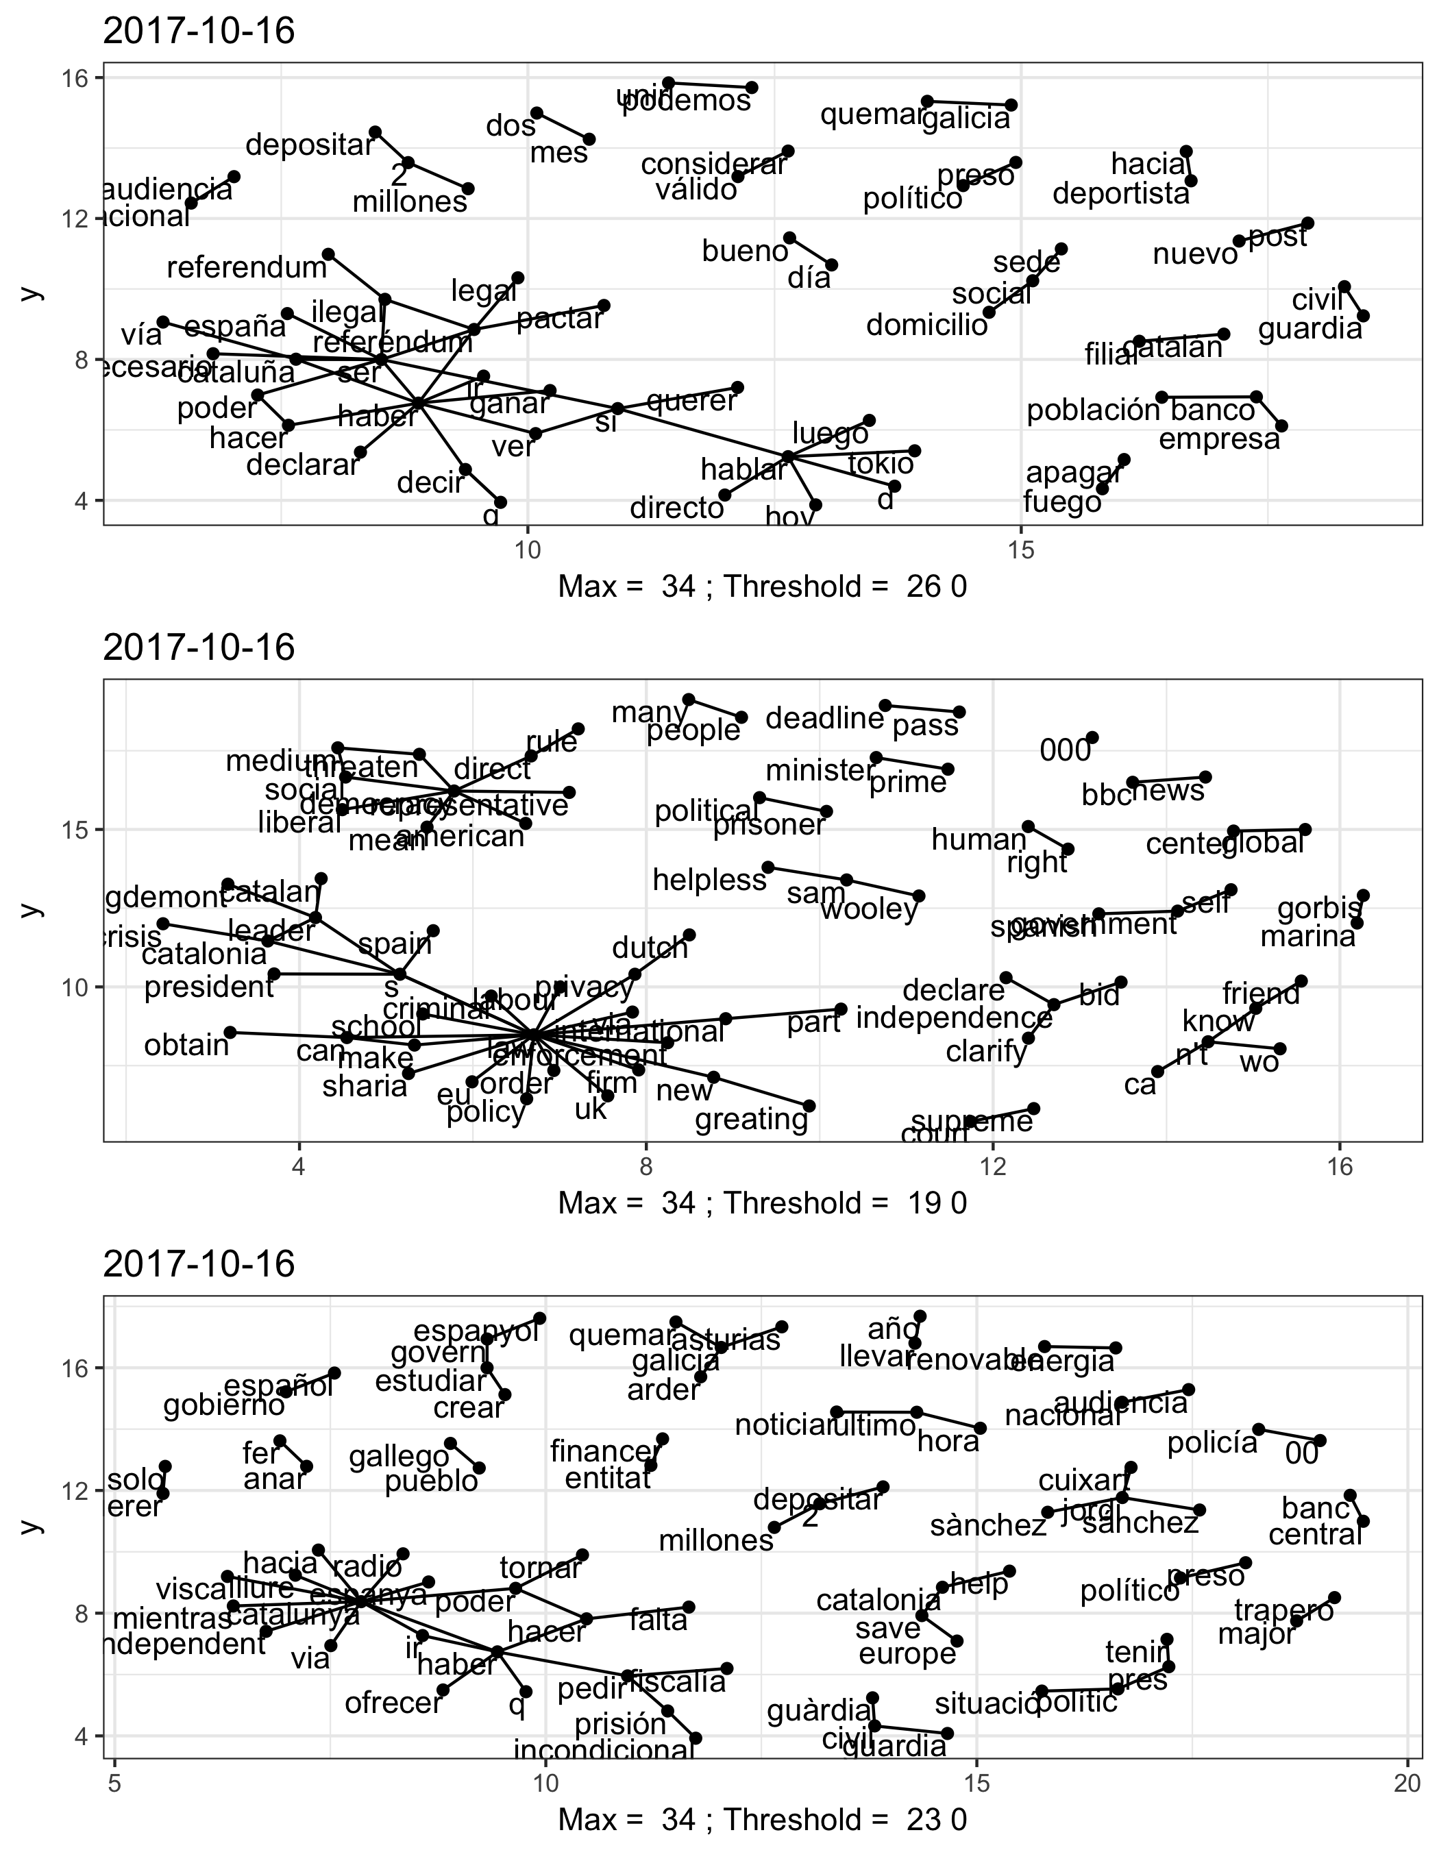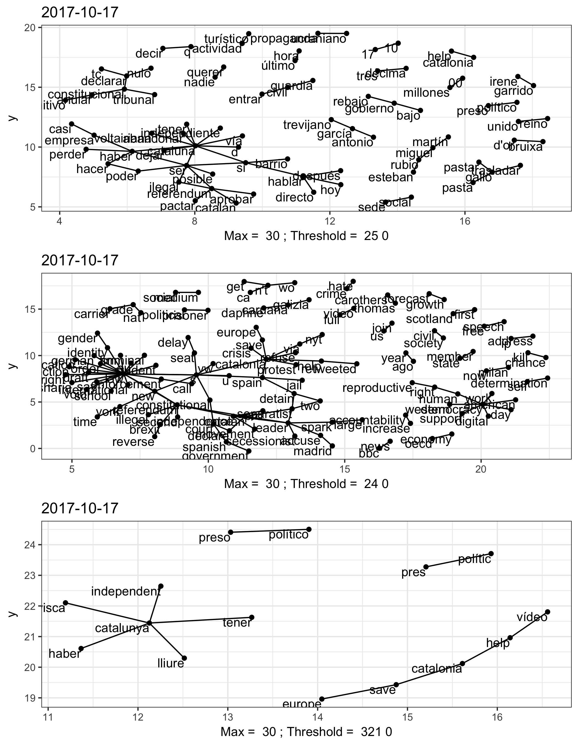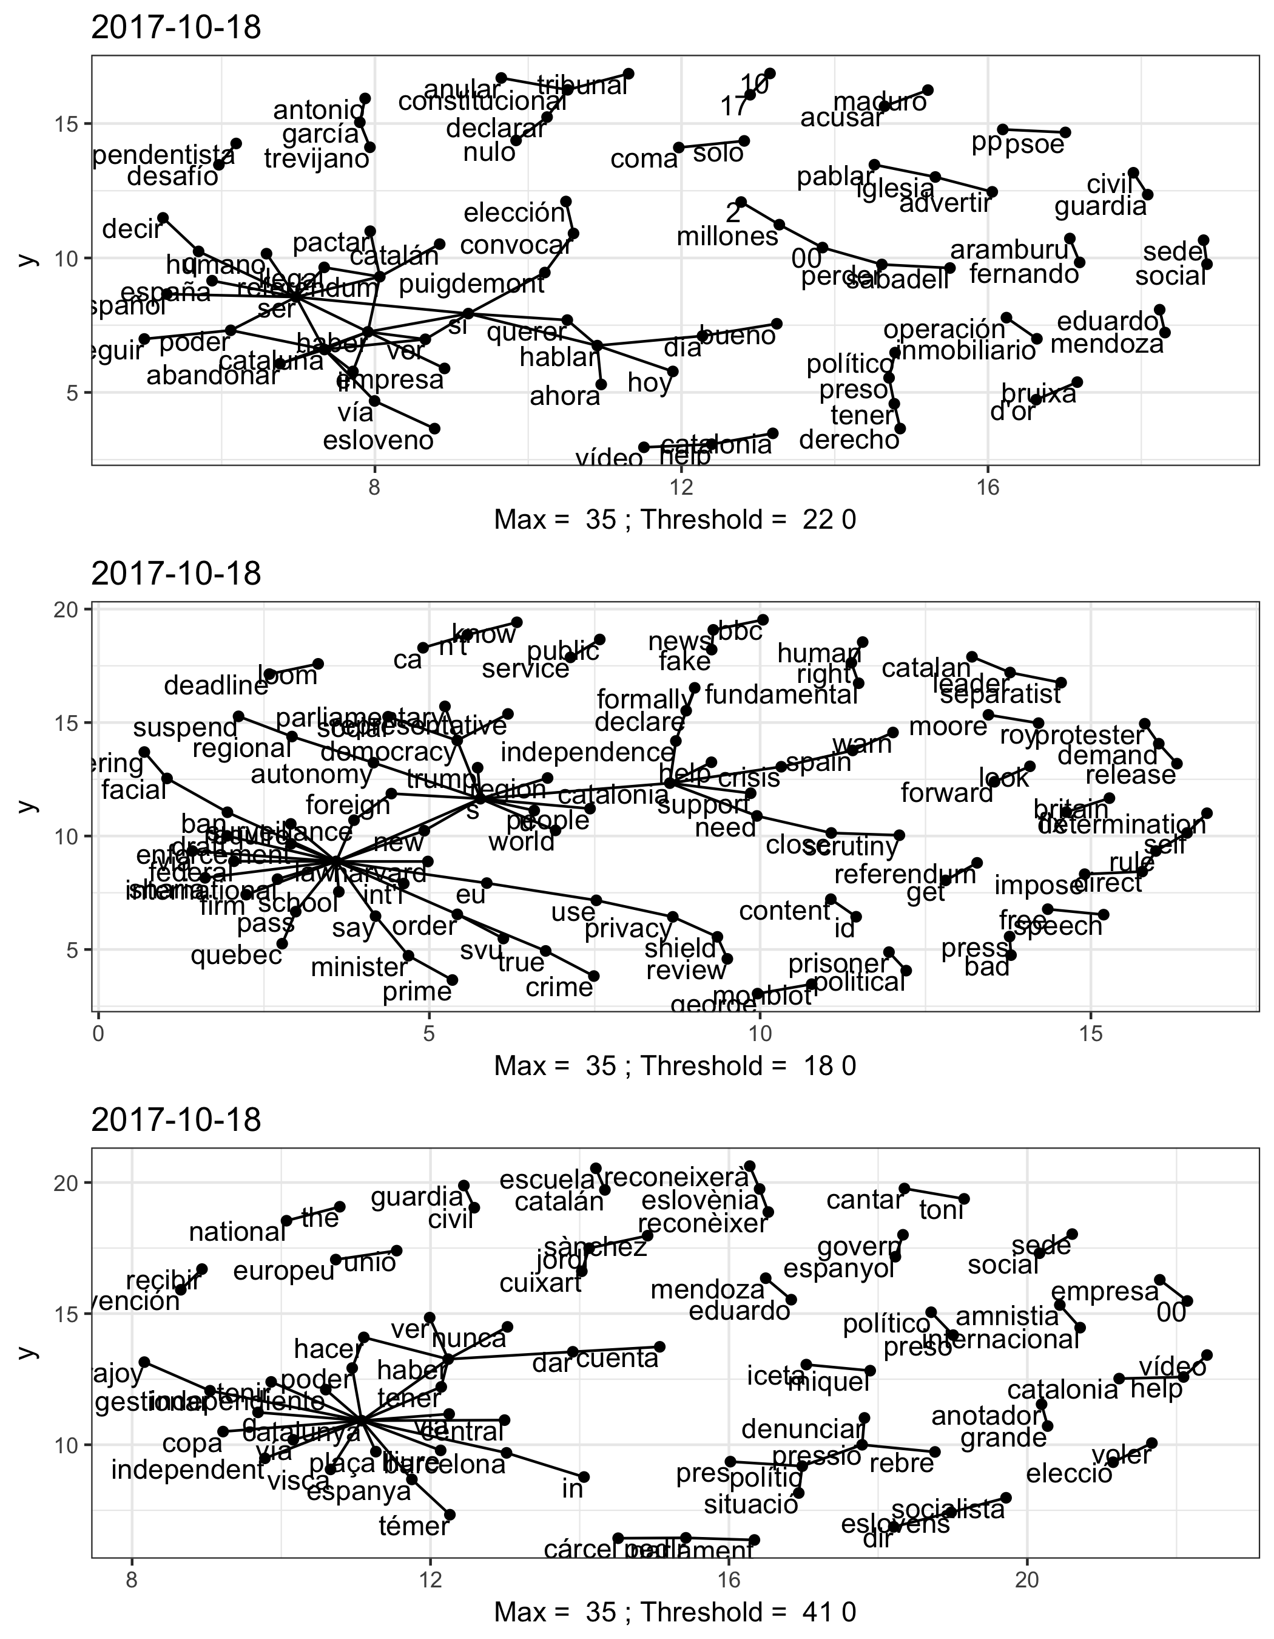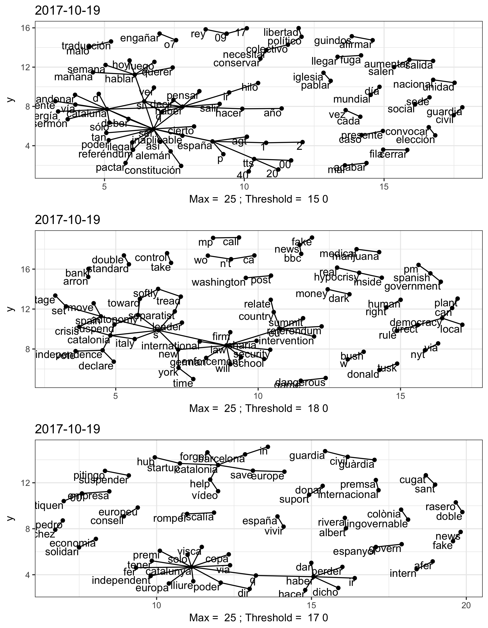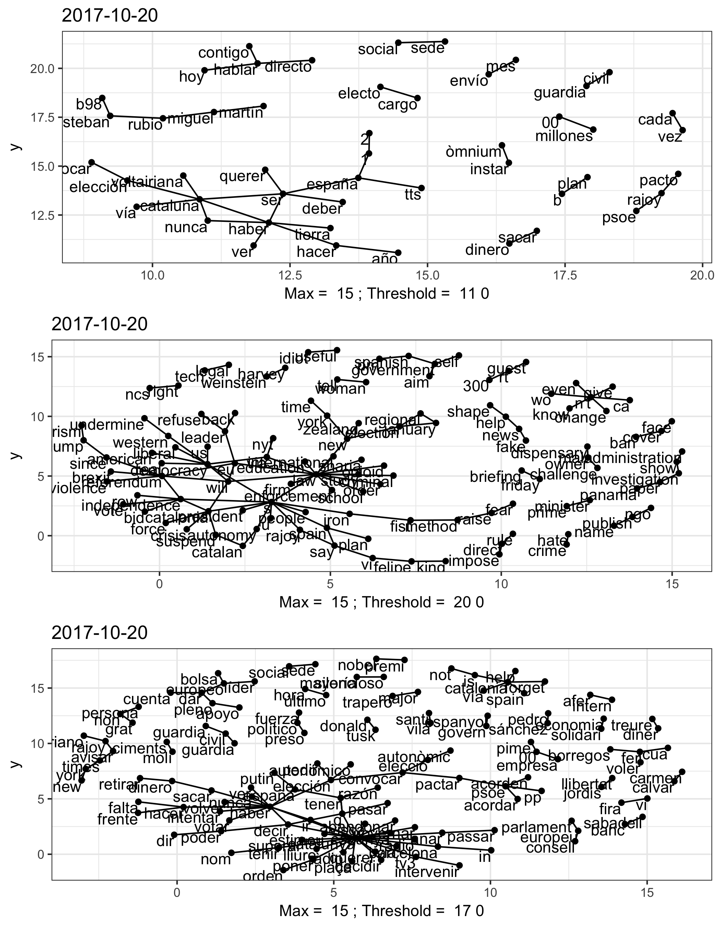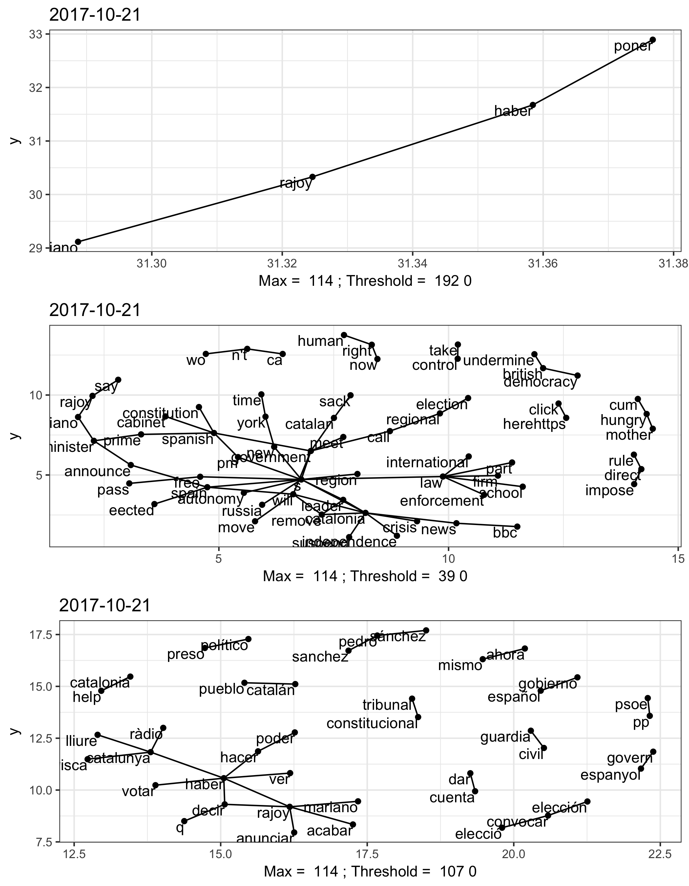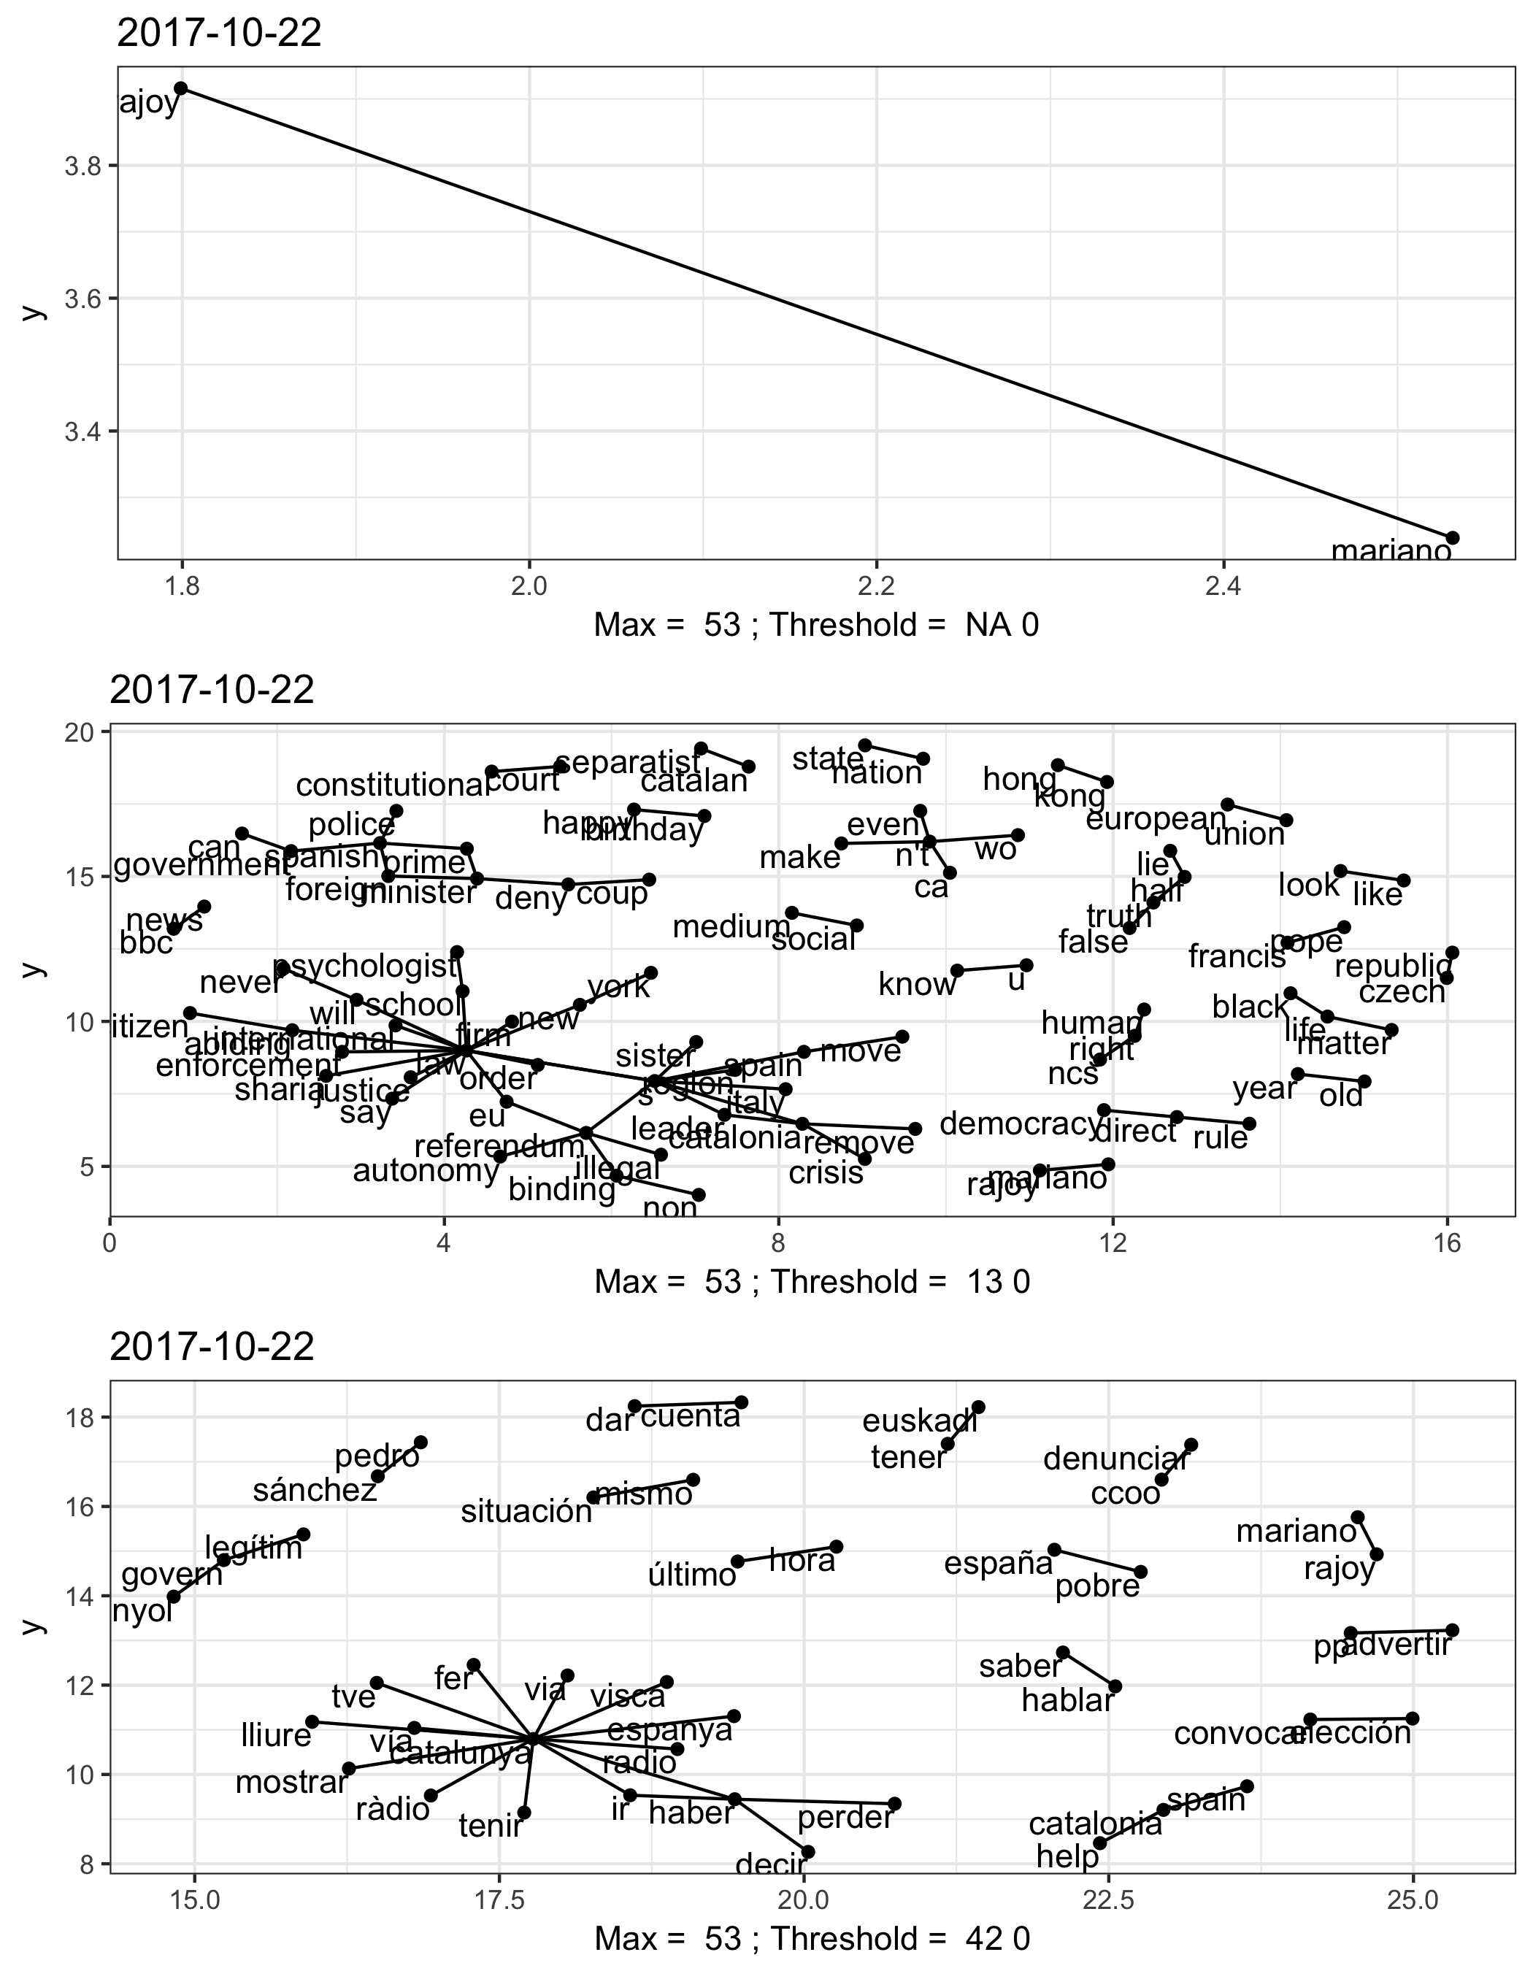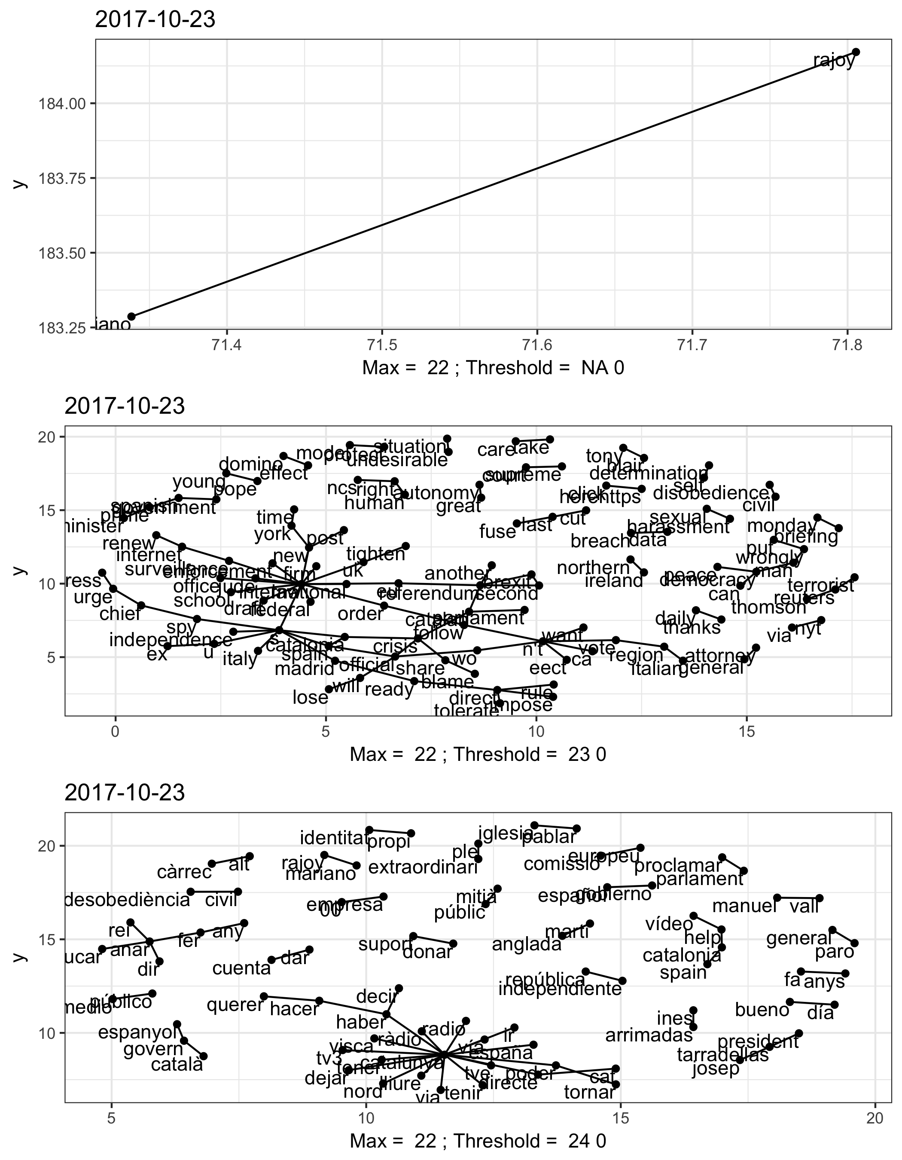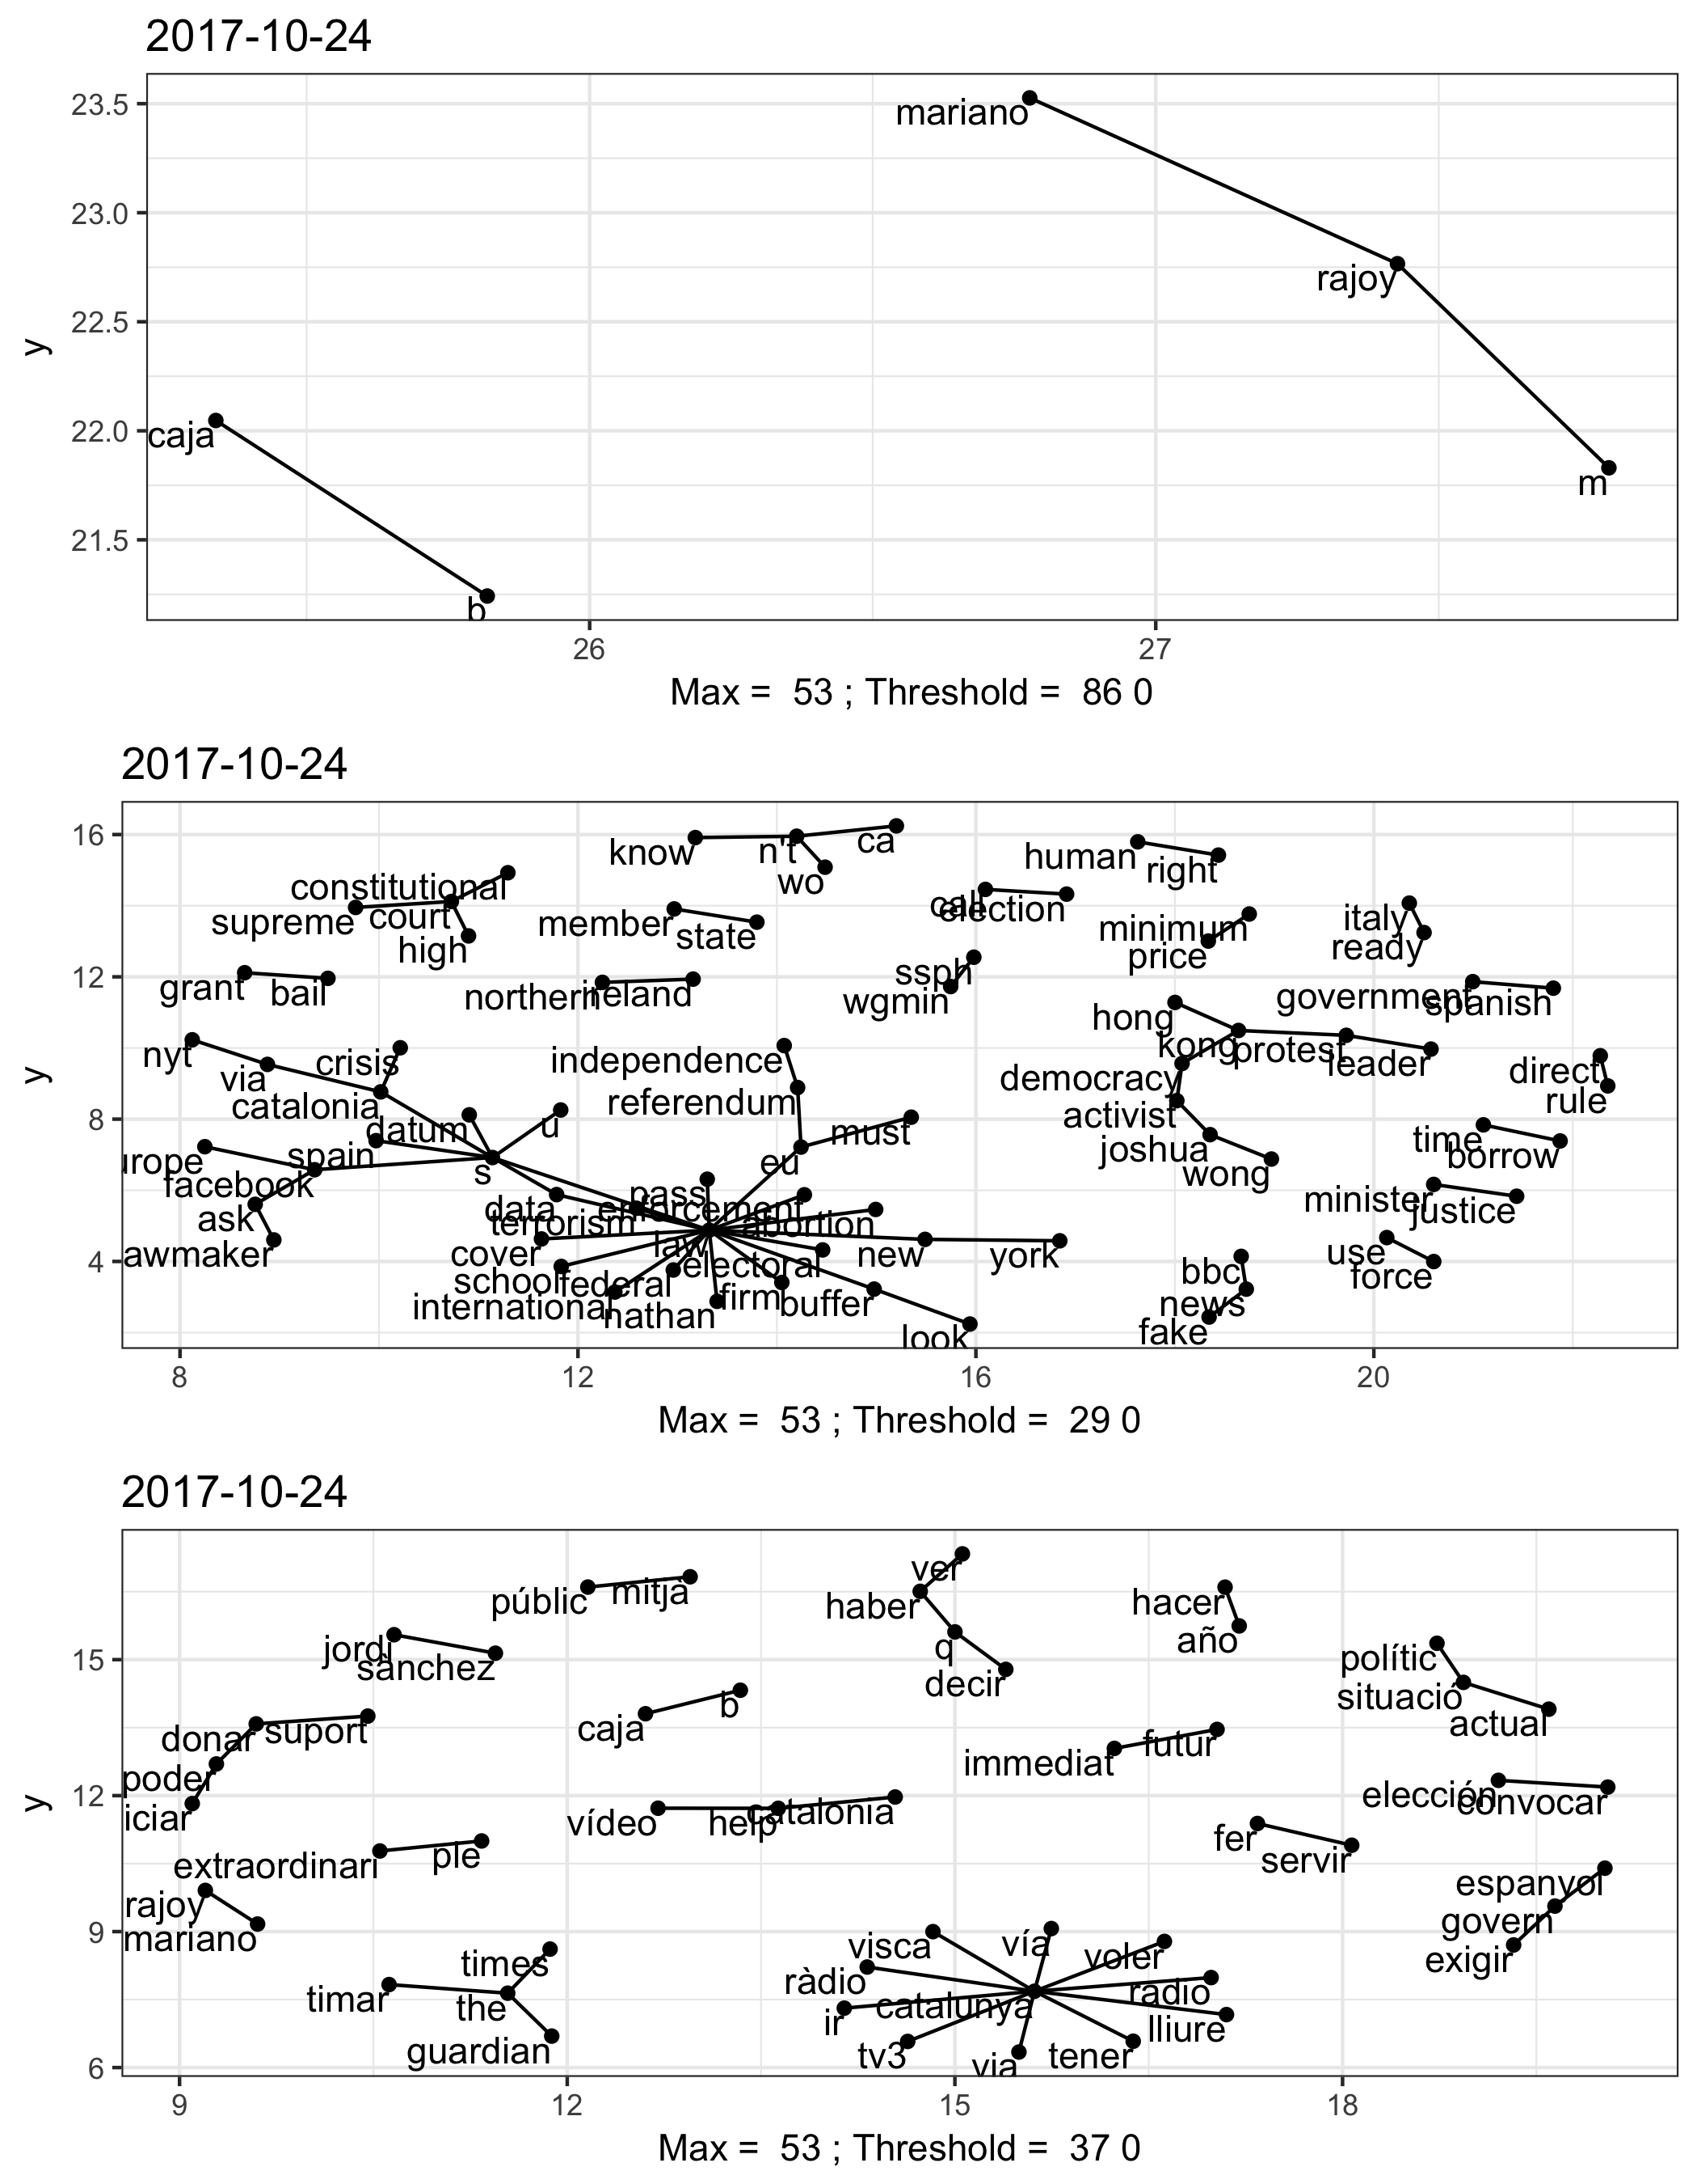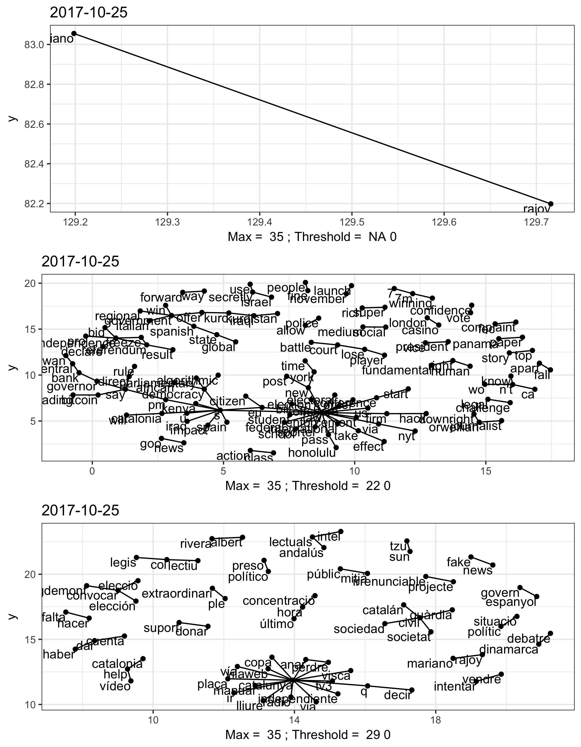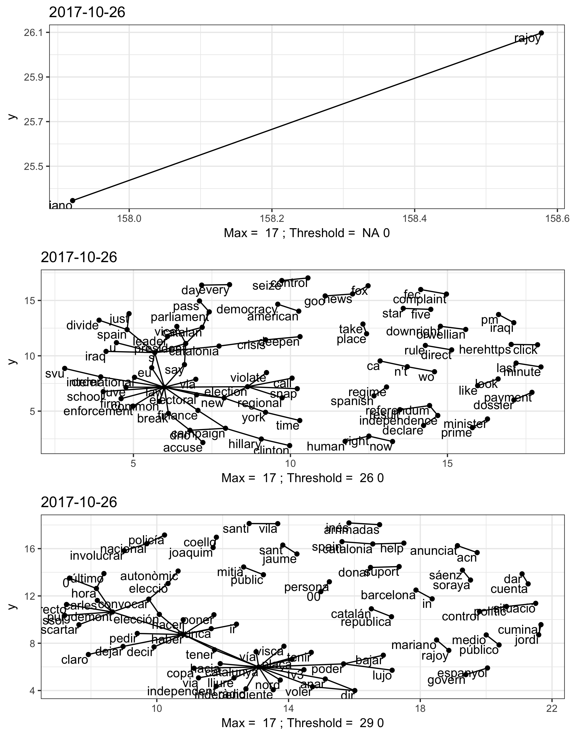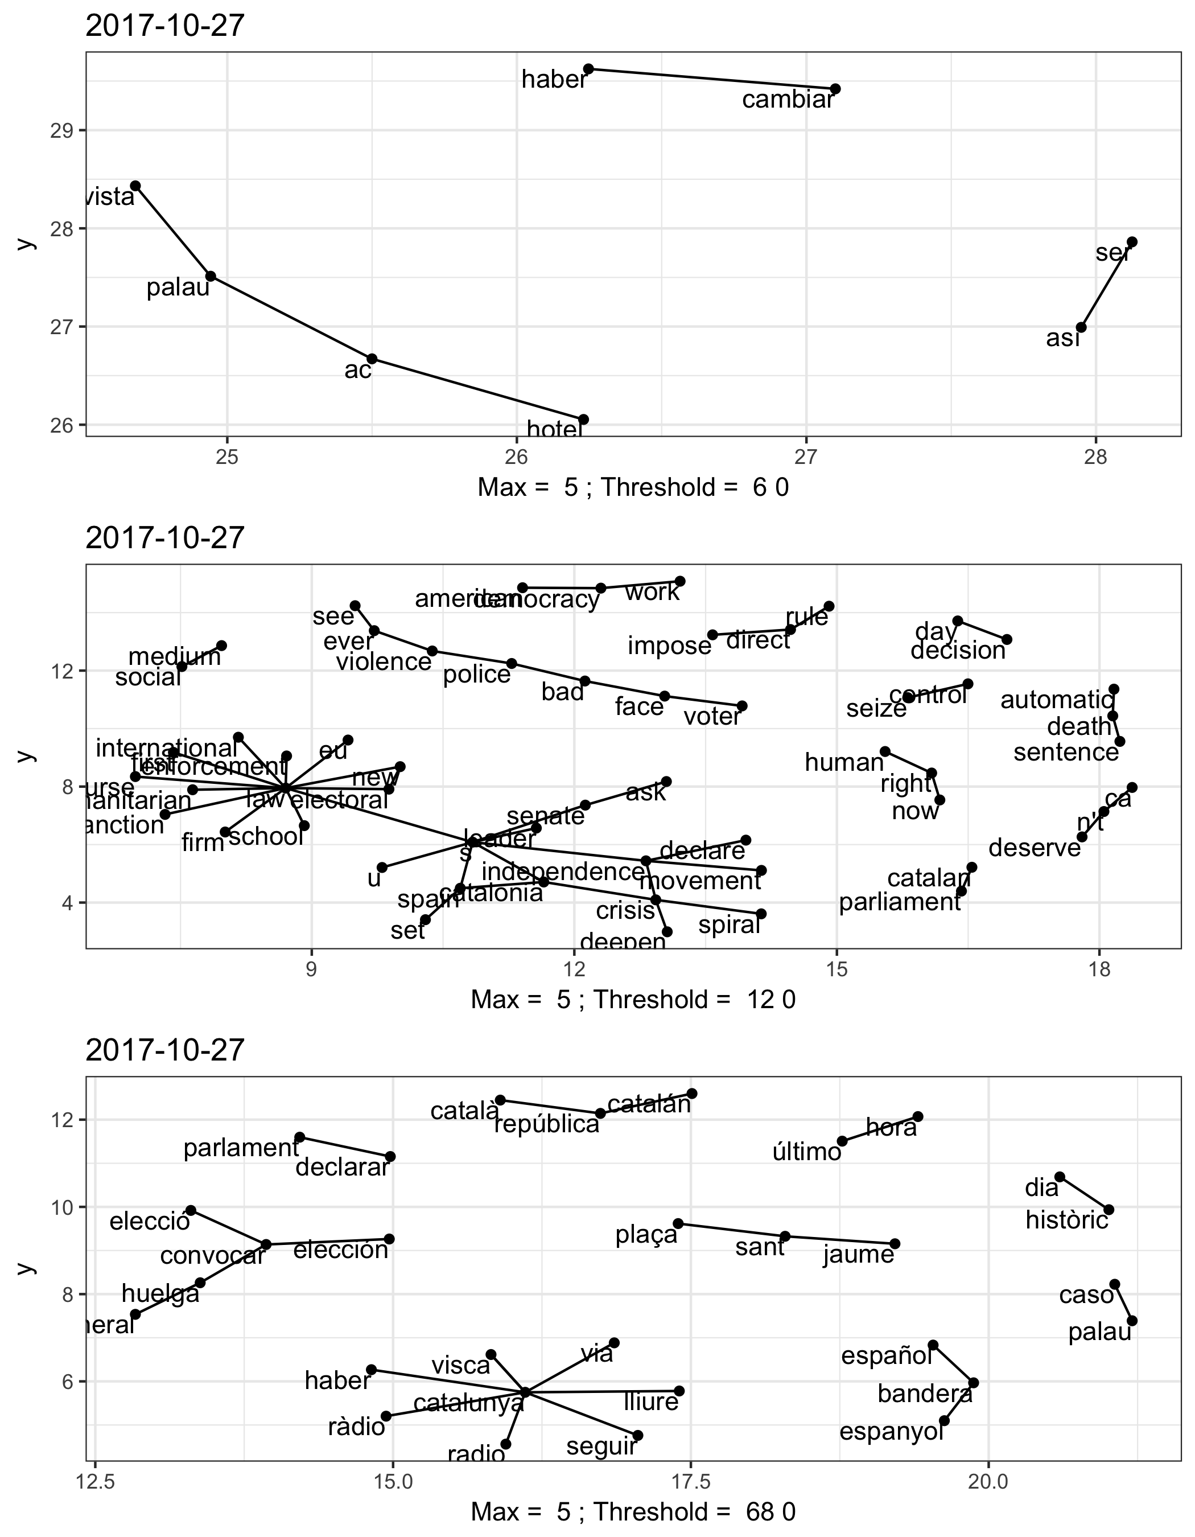

## created word n  
## 3 2017-09-30 22:00:00 día 11  
## 8 2017-09-30 22:00:00 poder 11  
## 13 2017-09-30 22:00:00 vía 11  
## 1 2017-09-30 22:00:00 catalán 12  
## 6 2017-09-30 22:00:00 mañana 12  
## 7 2017-09-30 22:00:00 pasar 12  
## 12 2017-09-30 22:00:00 ver 12  
## 2 2017-09-30 22:00:00 decir 13  
## 9 2017-09-30 22:00:00 querer 14  
## 11 2017-09-30 22:00:00 tener 17  
## 5 2017-09-30 22:00:00 hacer 18  
## 14 2017-09-30 22:00:00 votar 22  
## 10 2017-09-30 22:00:00 si 23  
## 4 2017-09-30 22:00:00 españa 25  
## 17 2017-09-30 23:00:00 tener 11  
## 16 2017-09-30 23:00:00 si 14  
## 15 2017-09-30 23:00:00 españa 15  
## 20 2017-10-01 05:00:00 ir 12  
## 22 2017-10-01 05:00:00 votar 13  
## 19 2017-10-01 05:00:00 directo 15  
## 21 2017-10-01 05:00:00 urna 15  
## 18 2017-10-01 05:00:00 colegio 17  
## 23 2017-10-01 06:00:00 anunciar 11  
## 27 2017-10-01 06:00:00 govern 12  
## 29 2017-10-01 06:00:00 ir 14  
## 24 2017-10-01 06:00:00 censo 15  
## 30 2017-10-01 06:00:00 poder 15  
## 31 2017-10-01 06:00:00 universal 15  
## 26 2017-10-01 06:00:00 cualquier 17  
## 28 2017-10-01 06:00:00 hacer 19  
## 25 2017-10-01 06:00:00 colegio 30  
## 32 2017-10-01 06:00:00 votar 33  
## 33 2017-10-01 09:00:00 hacer 11  
## 34 2017-10-01 10:00:00 catalán 11  
## 39 2017-10-01 10:00:00 gracia 11  
## 36 2017-10-01 10:00:00 decir 12  
## 46 2017-10-01 10:00:00 persona 12  
## 48 2017-10-01 10:00:00 policial 12  
## 45 2017-10-01 10:00:00 perder 13  
## 53 2017-10-01 10:00:00 vergüenza 13  
## 49 2017-10-01 10:00:00 querer 14  
## 38 2017-10-01 10:00:00 gobierno 17  
## 52 2017-10-01 10:00:00 ver 17  
## 47 2017-10-01 10:00:00 policía 18  
## 51 2017-10-01 10:00:00 tener 18  
## 35 2017-10-01 10:00:00 dar 21  
## 54 2017-10-01 10:00:00 votar 21  
## 43 2017-10-01 10:00:00 ir 22  
## 42 2017-10-01 10:00:00 ilegal 24  
## 44 2017-10-01 10:00:00 pasar 25  
## 50 2017-10-01 10:00:00 si 29  
## 40 2017-10-01 10:00:00 hacer 30  
## 41 2017-10-01 10:00:00 hoy 33  
## 37 2017-10-01 10:00:00 españa 35  
## 56 2017-10-01 11:00:00 así 11  
## 78 2017-10-01 11:00:00 niño 11  
## 79 2017-10-01 11:00:00 partido 11  
## 81 2017-10-01 11:00:00 pedir 11  
## 88 2017-10-01 11:00:00 represión 11  
## 60 2017-10-01 11:00:00 cosa 12  
## 76 2017-10-01 11:00:00 imagen 12  
## 55 2017-10-01 11:00:00 aquí 13  
## 82 2017-10-01 11:00:00 perder 13  
## 64 2017-10-01 11:00:00 directo 14  
## 70 2017-10-01 11:00:00 goma 14  
## 93 2017-10-01 11:00:00 vergüenza 14  
## 94 2017-10-01 11:00:00 vía 14  
## 63 2017-10-01 11:00:00 derecho 15  
## 66 2017-10-01 11:00:00 español 15  
## 97 2017-10-01 11:00:00 voto 15  
## 59 2017-10-01 11:00:00 colegio 16  
## 89 2017-10-01 11:00:00 saber 16  
## 73 2017-10-01 11:00:00 herir 17  
## 85 2017-10-01 11:00:00 policial 17  
## 58 2017-10-01 11:00:00 civil 18  
## 62 2017-10-01 11:00:00 decir 18  
## 67 2017-10-01 11:00:00 favor 18  
## 69 2017-10-01 11:00:00 gobierno 18  
## 71 2017-10-01 11:00:00 guardia 18  
## 57 2017-10-01 11:00:00 catalán 19  
## 87 2017-10-01 11:00:00 referendum 19  
## 68 2017-10-01 11:00:00 gente 20  
## 95 2017-10-01 11:00:00 vivir 20  
## 83 2017-10-01 11:00:00 poder 21  
## 61 2017-10-01 11:00:00 dar 27  
## 75 2017-10-01 11:00:00 ilegal 32  
## 77 2017-10-01 11:00:00 ir 32  
## 80 2017-10-01 11:00:00 pasar 32  
## 86 2017-10-01 11:00:00 querer 32  
## 84 2017-10-01 11:00:00 policía 34  
## 91 2017-10-01 11:00:00 tener 42  
## 92 2017-10-01 11:00:00 ver 44  
## 72 2017-10-01 11:00:00 hacer 45  
## 96 2017-10-01 11:00:00 votar 47  
## 90 2017-10-01 11:00:00 si 49  
## 74 2017-10-01 11:00:00 hoy 57  
## 65 2017-10-01 11:00:00 españa 61  
## 104 2017-10-01 12:00:00 carga 11  
## 115 2017-10-01 12:00:00 derecho 11  
## 118 2017-10-01 12:00:00 dos 11  
## 124 2017-10-01 12:00:00 goma 11  
## 140 2017-10-01 12:00:00 nacional 11  
## 164 2017-10-01 12:00:00 suspender 11  
## 166 2017-10-01 12:00:00 tras 11  
## 98 2017-10-01 12:00:00 actuar 12  
## 101 2017-10-01 12:00:00 apoyo 12  
## 103 2017-10-01 12:00:00 calle 12  
## 125 2017-10-01 12:00:00 gracia 12  
## 131 2017-10-01 12:00:00 imagen 12  
## 146 2017-10-01 12:00:00 pedir 12  
## 162 2017-10-01 12:00:00 situación 12  
## 100 2017-10-01 12:00:00 alguno 13  
## 108 2017-10-01 12:00:00 cosa 13  
## 136 2017-10-01 12:00:00 madrid 13  
## 141 2017-10-01 12:00:00 ocurrir 13  
## 159 2017-10-01 12:00:00 seguir 13  
## 161 2017-10-01 12:00:00 siempre 13  
## 99 2017-10-01 12:00:00 ahora 14  
## 107 2017-10-01 12:00:00 colegio 14  
## 112 2017-10-01 12:00:00 defender 14  
## 138 2017-10-01 12:00:00 mossos 14  
## 144 2017-10-01 12:00:00 partido 14  
## 151 2017-10-01 12:00:00 político 14  
## 153 2017-10-01 12:00:00 prohibir 14  
## 157 2017-10-01 12:00:00 represión 14  
## 158 2017-10-01 12:00:00 saber 14  
## 169 2017-10-01 12:00:00 vía 14  
## 110 2017-10-01 12:00:00 deber 15  
## 142 2017-10-01 12:00:00 país 15  
## 143 2017-10-01 12:00:00 parecer 15  
## 147 2017-10-01 12:00:00 perder 15  
## 106 2017-10-01 12:00:00 civil 16  
## 113 2017-10-01 12:00:00 dejar 16  
## 116 2017-10-01 12:00:00 día 16  
## 126 2017-10-01 12:00:00 guardia 16  
## 135 2017-10-01 12:00:00 llevar 16  
## 139 2017-10-01 12:00:00 mundo 16  
## 102 2017-10-01 12:00:00 así 17  
## 121 2017-10-01 12:00:00 favor 17  
## 134 2017-10-01 12:00:00 ley 17  
## 152 2017-10-01 12:00:00 pp 17  
## 132 2017-10-01 12:00:00 independencia 18  
## 128 2017-10-01 12:00:00 herir 19  
## 137 2017-10-01 12:00:00 mismo 21  
## 170 2017-10-01 12:00:00 violencia 21  
## 150 2017-10-01 12:00:00 policial 22  
## 154 2017-10-01 12:00:00 pueblo 22  
## 163 2017-10-01 12:00:00 solo 22  
## 171 2017-10-01 12:00:00 vivir 22  
## 156 2017-10-01 12:00:00 referendum 26  
## 117 2017-10-01 12:00:00 directo 29  
## 120 2017-10-01 12:00:00 español 29  
## 114 2017-10-01 12:00:00 democracia 30  
## 148 2017-10-01 12:00:00 poder 30  
## 168 2017-10-01 12:00:00 vergüenza 31  
## 130 2017-10-01 12:00:00 ilegal 34  
## 122 2017-10-01 12:00:00 gente 35  
## 105 2017-10-01 12:00:00 catalán 36  
## 109 2017-10-01 12:00:00 dar 39  
## 123 2017-10-01 12:00:00 gobierno 39  
## 145 2017-10-01 12:00:00 pasar 39  
## 149 2017-10-01 12:00:00 policía 40  
## 111 2017-10-01 12:00:00 decir 42  
## 155 2017-10-01 12:00:00 querer 47  
## 133 2017-10-01 12:00:00 ir 50  
## 165 2017-10-01 12:00:00 tener 51  
## 167 2017-10-01 12:00:00 ver 53  
## 160 2017-10-01 12:00:00 si 68  
## 172 2017-10-01 12:00:00 votar 69  
## 129 2017-10-01 12:00:00 hoy 72  
## 119 2017-10-01 12:00:00 españa 73  
## 127 2017-10-01 12:00:00 hacer 77  
## 173 2017-10-01 13:00:00 así 11  
## 176 2017-10-01 13:00:00 deber 11  
## 185 2017-10-01 13:00:00 herir 11  
## 190 2017-10-01 13:00:00 poder 11  
## 175 2017-10-01 13:00:00 dar 12  
## 178 2017-10-01 13:00:00 derecho 12  
## 179 2017-10-01 13:00:00 directo 12  
## 187 2017-10-01 13:00:00 ilegal 12  
## 197 2017-10-01 13:00:00 vergüenza 12  
## 181 2017-10-01 13:00:00 español 14  
## 192 2017-10-01 13:00:00 pueblo 14  
## 198 2017-10-01 13:00:00 violencia 14  
## 199 2017-10-01 13:00:00 vivir 14  
## 174 2017-10-01 13:00:00 catalán 15  
## 182 2017-10-01 13:00:00 gente 16  
## 183 2017-10-01 13:00:00 gobierno 16  
## 193 2017-10-01 13:00:00 querer 19  
## 191 2017-10-01 13:00:00 policial 20  
## 177 2017-10-01 13:00:00 decir 21  
## 200 2017-10-01 13:00:00 votar 21  
## 188 2017-10-01 13:00:00 ir 22  
## 189 2017-10-01 13:00:00 pasar 22  
## 194 2017-10-01 13:00:00 si 25  
## 195 2017-10-01 13:00:00 tener 26  
## 184 2017-10-01 13:00:00 hacer 28  
## 196 2017-10-01 13:00:00 ver 28  
## 180 2017-10-01 13:00:00 españa 32  
## 186 2017-10-01 13:00:00 hoy 57  
## 201 2017-10-01 14:00:00 decir 11  
## 206 2017-10-01 14:00:00 votar 11  
## 202 2017-10-01 14:00:00 españa 12  
## 203 2017-10-01 14:00:00 hacer 14  
## 205 2017-10-01 14:00:00 tener 16  
## 204 2017-10-01 14:00:00 hoy 20  
## 208 2017-10-01 15:00:00 colegio 11  
## 215 2017-10-01 15:00:00 guardia 11  
## 211 2017-10-01 15:00:00 día 12  
## 213 2017-10-01 15:00:00 español 12  
## 214 2017-10-01 15:00:00 gente 12  
## 221 2017-10-01 15:00:00 poder 12  
## 228 2017-10-01 15:00:00 ver 12  
## 223 2017-10-01 15:00:00 policial 13  
## 225 2017-10-01 15:00:00 referendum 13  
## 207 2017-10-01 15:00:00 catalán 14  
## 224 2017-10-01 15:00:00 pp 14  
## 226 2017-10-01 15:00:00 si 14  
## 222 2017-10-01 15:00:00 policía 15  
## 229 2017-10-01 15:00:00 vergüenza 15  
## 216 2017-10-01 15:00:00 hacer 16  
## 217 2017-10-01 15:00:00 herir 16  
## 220 2017-10-01 15:00:00 ir 16  
## 209 2017-10-01 15:00:00 dar 17  
## 219 2017-10-01 15:00:00 ilegal 17  
## 230 2017-10-01 15:00:00 votar 19  
## 210 2017-10-01 15:00:00 decir 21  
## 218 2017-10-01 15:00:00 hoy 28  
## 212 2017-10-01 15:00:00 españa 30  
## 227 2017-10-01 15:00:00 tener 32  
## 247 2017-10-01 16:00:00 madrid 11  
## 250 2017-10-01 16:00:00 persona 11  
## 253 2017-10-01 16:00:00 pueblo 11  
## 260 2017-10-01 16:00:00 violencia 11  
## 241 2017-10-01 16:00:00 gente 12  
## 248 2017-10-01 16:00:00 mossos 12  
## 258 2017-10-01 16:00:00 vez 12  
## 259 2017-10-01 16:00:00 vía 12  
## 233 2017-10-01 16:00:00 colegio 13  
## 242 2017-10-01 16:00:00 gobierno 14  
## 261 2017-10-01 16:00:00 vivir 14  
## 231 2017-10-01 16:00:00 ahora 15  
## 237 2017-10-01 16:00:00 día 15  
## 236 2017-10-01 16:00:00 dejar 16  
## 240 2017-10-01 16:00:00 español 17  
## 252 2017-10-01 16:00:00 policía 18  
## 234 2017-10-01 16:00:00 dar 20  
## 251 2017-10-01 16:00:00 poder 20  
## 232 2017-10-01 16:00:00 catalán 21  
## 254 2017-10-01 16:00:00 querer 22  
## 235 2017-10-01 16:00:00 decir 23  
## 249 2017-10-01 16:00:00 pasar 23  
## 256 2017-10-01 16:00:00 tener 24  
## 238 2017-10-01 16:00:00 directo 25  
## 246 2017-10-01 16:00:00 ir 26  
## 239 2017-10-01 16:00:00 españa 29  
## 245 2017-10-01 16:00:00 ilegal 29  
## 257 2017-10-01 16:00:00 ver 29  
## 243 2017-10-01 16:00:00 hacer 32  
## 255 2017-10-01 16:00:00 si 36  
## 262 2017-10-01 16:00:00 votar 38  
## 244 2017-10-01 16:00:00 hoy 49  
## 280 2017-10-01 17:00:00 fuerza 11  
## 283 2017-10-01 17:00:00 guardia 11  
## 288 2017-10-01 17:00:00 imagen 11  
## 292 2017-10-01 17:00:00 menos 11  
## 293 2017-10-01 17:00:00 mismo 11  
## 294 2017-10-01 17:00:00 nunca 11  
## 299 2017-10-01 17:00:00 policial 11  
## 301 2017-10-01 17:00:00 pp 11  
## 305 2017-10-01 17:00:00 quedar 11  
## 317 2017-10-01 17:00:00 vergüenza 11  
## 272 2017-10-01 17:00:00 defender 12  
## 273 2017-10-01 17:00:00 dejar 12  
## 303 2017-10-01 17:00:00 puerta 12  
## 315 2017-10-01 17:00:00 urna 12  
## 264 2017-10-01 17:00:00 año 13  
## 267 2017-10-01 17:00:00 ciudadano 13  
## 285 2017-10-01 17:00:00 herir 14  
## 300 2017-10-01 17:00:00 político 15  
## 308 2017-10-01 17:00:00 represión 15  
## 309 2017-10-01 17:00:00 saber 15  
## 310 2017-10-01 17:00:00 seguir 15  
## 321 2017-10-01 17:00:00 vivir 15  
## 270 2017-10-01 17:00:00 deber 16  
## 277 2017-10-01 17:00:00 directo 16  
## 296 2017-10-01 17:00:00 piqué 16  
## 307 2017-10-01 17:00:00 referendum 16  
## 318 2017-10-01 17:00:00 vez 17  
## 313 2017-10-01 17:00:00 solo 18  
## 263 2017-10-01 17:00:00 ahora 19  
## 320 2017-10-01 17:00:00 violencia 19  
## 302 2017-10-01 17:00:00 pueblo 20  
## 319 2017-10-01 17:00:00 vía 20  
## 265 2017-10-01 17:00:00 así 21  
## 290 2017-10-01 17:00:00 ley 21  
## 275 2017-10-01 17:00:00 derecho 22  
## 276 2017-10-01 17:00:00 día 22  
## 291 2017-10-01 17:00:00 madrid 22  
## 298 2017-10-01 17:00:00 policía 22  
## 312 2017-10-01 17:00:00 sol 22  
## 271 2017-10-01 17:00:00 decir 23  
## 266 2017-10-01 17:00:00 catalán 24  
## 274 2017-10-01 17:00:00 democracia 24  
## 282 2017-10-01 17:00:00 gobierno 26  
## 287 2017-10-01 17:00:00 ilegal 26  
## 281 2017-10-01 17:00:00 gente 28  
## 295 2017-10-01 17:00:00 pasar 29  
## 269 2017-10-01 17:00:00 dar 33  
## 279 2017-10-01 17:00:00 español 33  
## 268 2017-10-01 17:00:00 constitución 34  
## 306 2017-10-01 17:00:00 querer 35  
## 304 2017-10-01 17:00:00 puigdemont 39  
## 297 2017-10-01 17:00:00 poder 40  
## 316 2017-10-01 17:00:00 ver 40  
## 289 2017-10-01 17:00:00 ir 47  
## 322 2017-10-01 17:00:00 votar 48  
## 314 2017-10-01 17:00:00 tener 49  
## 311 2017-10-01 17:00:00 si 51  
## 284 2017-10-01 17:00:00 hacer 55  
## 286 2017-10-01 17:00:00 hoy 78  
## 278 2017-10-01 17:00:00 españa 97  
## 324 2017-10-01 18:00:00 así 11  
## 329 2017-10-01 18:00:00 defender 11  
## 331 2017-10-01 18:00:00 democracia 11  
## 333 2017-10-01 18:00:00 directo 11  
## 335 2017-10-01 18:00:00 español 11  
## 343 2017-10-01 18:00:00 ley 11  
## 345 2017-10-01 18:00:00 mayoría 11  
## 353 2017-10-01 18:00:00 policial 11  
## 360 2017-10-01 18:00:00 seguir 11  
## 366 2017-10-01 18:00:00 vergüenza 11  
## 347 2017-10-01 18:00:00 mundo 12  
## 358 2017-10-01 18:00:00 salir 12  
## 332 2017-10-01 18:00:00 derecho 13  
## 344 2017-10-01 18:00:00 madrid 13  
## 352 2017-10-01 18:00:00 policía 14  
## 330 2017-10-01 18:00:00 dejar 15  
## 341 2017-10-01 18:00:00 ilegal 15  
## 348 2017-10-01 18:00:00 pasar 15  
## 350 2017-10-01 18:00:00 pedro 15  
## 354 2017-10-01 18:00:00 político 15  
## 367 2017-10-01 18:00:00 violencia 15  
## 336 2017-10-01 18:00:00 gente 16  
## 349 2017-10-01 18:00:00 pedir 17  
## 359 2017-10-01 18:00:00 sánchez 17  
## 362 2017-10-01 18:00:00 sol 18  
## 363 2017-10-01 18:00:00 solo 18  
## 346 2017-10-01 18:00:00 mismo 19  
## 323 2017-10-01 18:00:00 ahora 20  
## 327 2017-10-01 18:00:00 dar 21  
## 355 2017-10-01 18:00:00 pueblo 21  
## 357 2017-10-01 18:00:00 querer 22  
## 325 2017-10-01 18:00:00 catalán 24  
## 337 2017-10-01 18:00:00 gobierno 24  
## 365 2017-10-01 18:00:00 ver 26  
## 339 2017-10-01 18:00:00 herir 28  
## 326 2017-10-01 18:00:00 constitución 30  
## 342 2017-10-01 18:00:00 ir 30  
## 351 2017-10-01 18:00:00 poder 31  
## 338 2017-10-01 18:00:00 hacer 33  
## 368 2017-10-01 18:00:00 votar 34  
## 361 2017-10-01 18:00:00 si 36  
## 328 2017-10-01 18:00:00 decir 38  
## 334 2017-10-01 18:00:00 españa 48  
## 364 2017-10-01 18:00:00 tener 51  
## 340 2017-10-01 18:00:00 hoy 62  
## 356 2017-10-01 18:00:00 puigdemont 73  
## 372 2017-10-01 19:00:00 civil 11  
## 392 2017-10-01 19:00:00 herir 11  
## 397 2017-10-01 19:00:00 junqueras 11  
## 370 2017-10-01 19:00:00 así 12  
## 380 2017-10-01 19:00:00 dejar 12  
## 381 2017-10-01 19:00:00 democracia 12  
## 385 2017-10-01 19:00:00 elección 12  
## 401 2017-10-01 19:00:00 país 12  
## 409 2017-10-01 19:00:00 referendum 12  
## 375 2017-10-01 19:00:00 culpar 13  
## 383 2017-10-01 19:00:00 día 13  
## 390 2017-10-01 19:00:00 guardia 13  
## 400 2017-10-01 19:00:00 mismo 13  
## 369 2017-10-01 19:00:00 ahora 14  
## 395 2017-10-01 19:00:00 imagen 14  
## 399 2017-10-01 19:00:00 llevar 14  
## 403 2017-10-01 19:00:00 pedir 14  
## 382 2017-10-01 19:00:00 derecho 15  
## 384 2017-10-01 19:00:00 directo 15  
## 398 2017-10-01 19:00:00 ley 15  
## 402 2017-10-01 19:00:00 pasar 15  
## 373 2017-10-01 19:00:00 claro 16  
## 379 2017-10-01 19:00:00 defender 16  
## 389 2017-10-01 19:00:00 gobierno 16  
## 406 2017-10-01 19:00:00 policial 17  
## 394 2017-10-01 19:00:00 ilegal 18  
## 410 2017-10-01 19:00:00 sánchez 18  
## 376 2017-10-01 19:00:00 dar 19  
## 388 2017-10-01 19:00:00 gente 19  
## 413 2017-10-01 19:00:00 ver 19  
## 405 2017-10-01 19:00:00 policía 20  
## 371 2017-10-01 19:00:00 catalán 21  
## 377 2017-10-01 19:00:00 deber 23  
## 387 2017-10-01 19:00:00 español 25  
## 408 2017-10-01 19:00:00 querer 30  
## 374 2017-10-01 19:00:00 constitución 32  
## 378 2017-10-01 19:00:00 decir 32  
## 414 2017-10-01 19:00:00 votar 32  
## 404 2017-10-01 19:00:00 poder 34  
## 396 2017-10-01 19:00:00 ir 37  
## 391 2017-10-01 19:00:00 hacer 39  
## 386 2017-10-01 19:00:00 españa 47  
## 411 2017-10-01 19:00:00 si 47  
## 393 2017-10-01 19:00:00 hoy 48  
## 412 2017-10-01 19:00:00 tener 48  
## 407 2017-10-01 19:00:00 puigdemont 93  
## 416 2017-10-01 20:00:00 hacer 11  
## 419 2017-10-01 20:00:00 tener 12  
## 415 2017-10-01 20:00:00 decir 15  
## 418 2017-10-01 20:00:00 resultado 15  
## 417 2017-10-01 20:00:00 puigdemont 18  
## 426 2017-10-01 21:00:00 español 11  
## 434 2017-10-01 21:00:00 policía 11  
## 441 2017-10-01 21:00:00 votar 11  
## 420 2017-10-01 21:00:00 catalán 12  
## 432 2017-10-01 21:00:00 pasar 12  
## 433 2017-10-01 21:00:00 poder 12  
## 436 2017-10-01 21:00:00 querer 12  
## 440 2017-10-01 21:00:00 ver 12  
## 424 2017-10-01 21:00:00 derecho 13  
## 437 2017-10-01 21:00:00 resultado 13  
## 421 2017-10-01 21:00:00 constitución 14  
## 422 2017-10-01 21:00:00 dar 14  
## 430 2017-10-01 21:00:00 independencia 16  
## 439 2017-10-01 21:00:00 tener 16  
## 423 2017-10-01 21:00:00 decir 17  
## 431 2017-10-01 21:00:00 ir 17  
## 427 2017-10-01 21:00:00 gobierno 18  
## 438 2017-10-01 21:00:00 si 21  
## 428 2017-10-01 21:00:00 hacer 30  
## 435 2017-10-01 21:00:00 puigdemont 30  
## 429 2017-10-01 21:00:00 hoy 35  
## 425 2017-10-01 21:00:00 españa 44  
## 442 2017-10-01 22:00:00 catalán 11  
## 447 2017-10-01 22:00:00 derecho 11  
## 457 2017-10-01 22:00:00 poder 11  
## 460 2017-10-01 22:00:00 referendum 11  
## 464 2017-10-01 22:00:00 vía 12  
## 454 2017-10-01 22:00:00 independencia 14  
## 456 2017-10-01 22:00:00 ley 14  
## 463 2017-10-01 22:00:00 ver 14  
## 446 2017-10-01 22:00:00 decir 16  
## 450 2017-10-01 22:00:00 gobierno 16  
## 453 2017-10-01 22:00:00 ilegal 16  
## 445 2017-10-01 22:00:00 deber 17  
## 449 2017-10-01 22:00:00 español 18  
## 462 2017-10-01 22:00:00 tener 19  
## 459 2017-10-01 22:00:00 querer 20  
## 444 2017-10-01 22:00:00 dar 24  
## 465 2017-10-01 22:00:00 votar 24  
## 452 2017-10-01 22:00:00 hoy 27  
## 451 2017-10-01 22:00:00 hacer 28  
## 443 2017-10-01 22:00:00 constitución 29  
## 455 2017-10-01 22:00:00 ir 29  
## 461 2017-10-01 22:00:00 si 30  
## 458 2017-10-01 22:00:00 puigdemont 31  
## 448 2017-10-01 22:00:00 españa 51  
## 468 2017-10-01 23:00:00 gobierno 11  
## 475 2017-10-01 23:00:00 querer 11  
## 469 2017-10-01 23:00:00 hacer 12  
## 472 2017-10-01 23:00:00 independencia 12  
## 471 2017-10-01 23:00:00 ilegal 14  
## 478 2017-10-01 23:00:00 ver 15  
## 470 2017-10-01 23:00:00 hoy 16  
## 479 2017-10-01 23:00:00 votar 18  
## 466 2017-10-01 23:00:00 constitución 19  
## 473 2017-10-01 23:00:00 ir 21  
## 477 2017-10-01 23:00:00 tener 21  
## 476 2017-10-01 23:00:00 si 25  
## 474 2017-10-01 23:00:00 puigdemont 31  
## 467 2017-10-01 23:00:00 españa 44  
## 491 2017-10-02 00:00:00 saber 11  
## 486 2017-10-02 00:00:00 hoy 12  
## 484 2017-10-02 00:00:00 español 13  
## 485 2017-10-02 00:00:00 hacer 13  
## 488 2017-10-02 00:00:00 ir 13  
## 490 2017-10-02 00:00:00 querer 13  
## 493 2017-10-02 00:00:00 tener 13  
## 487 2017-10-02 00:00:00 independencia 14  
## 480 2017-10-02 00:00:00 catalán 16  
## 482 2017-10-02 00:00:00 dar 16  
## 494 2017-10-02 00:00:00 votar 17  
## 492 2017-10-02 00:00:00 si 22  
## 481 2017-10-02 00:00:00 constitución 23  
## 489 2017-10-02 00:00:00 puigdemont 34  
## 483 2017-10-02 00:00:00 españa 35  
## 501 2017-10-02 01:00:00 ver 11  
## 498 2017-10-02 01:00:00 ir 12  
## 502 2017-10-02 01:00:00 votar 12  
## 497 2017-10-02 01:00:00 hoy 13  
## 499 2017-10-02 01:00:00 puigdemont 16  
## 500 2017-10-02 01:00:00 si 17  
## 496 2017-10-02 01:00:00 hacer 20  
## 495 2017-10-02 01:00:00 españa 39  
## 504 2017-10-02 02:00:00 si 11  
## 503 2017-10-02 02:00:00 españa 25  
## 508 2017-10-02 03:00:00 tener 11  
## 505 2017-10-02 03:00:00 constitución 12  
## 509 2017-10-02 03:00:00 votar 13  
## 507 2017-10-02 03:00:00 puigdemont 15  
## 506 2017-10-02 03:00:00 españa 27  
## 513 2017-10-02 04:00:00 puigdemont 11  
## 510 2017-10-02 04:00:00 catalán 12  
## 511 2017-10-02 04:00:00 día 12  
## 514 2017-10-02 04:00:00 tener 17  
## 512 2017-10-02 04:00:00 españa 31  
## 515 2017-10-02 05:00:00 dar 11  
## 521 2017-10-02 05:00:00 independencia 11  
## 516 2017-10-02 05:00:00 decir 12  
## 519 2017-10-02 05:00:00 hacer 12  
## 526 2017-10-02 05:00:00 votar 12  
## 517 2017-10-02 05:00:00 día 16  
## 520 2017-10-02 05:00:00 hoy 16  
## 525 2017-10-02 05:00:00 tener 17  
## 524 2017-10-02 05:00:00 si 18  
## 522 2017-10-02 05:00:00 ir 20  
## 523 2017-10-02 05:00:00 puigdemont 21  
## 518 2017-10-02 05:00:00 españa 48  
## 533 2017-10-02 06:00:00 derecho 11  
## 539 2017-10-02 06:00:00 mundo 11  
## 540 2017-10-02 06:00:00 país 11  
## 542 2017-10-02 06:00:00 resultado 11  
## 529 2017-10-02 06:00:00 catalán 12  
## 545 2017-10-02 06:00:00 vía 12  
## 532 2017-10-02 06:00:00 decir 13  
## 546 2017-10-02 06:00:00 votar 13  
## 527 2017-10-02 06:00:00 ahora 15  
## 531 2017-10-02 06:00:00 dar 15  
## 530 2017-10-02 06:00:00 constitución 16  
## 536 2017-10-02 06:00:00 hacer 16  
## 538 2017-10-02 06:00:00 independencia 16  
## 543 2017-10-02 06:00:00 si 17  
## 537 2017-10-02 06:00:00 hoy 20  
## 528 2017-10-02 06:00:00 ayer 21  
## 535 2017-10-02 06:00:00 gobierno 22  
## 544 2017-10-02 06:00:00 tener 23  
## 541 2017-10-02 06:00:00 puigdemont 27  
## 534 2017-10-02 06:00:00 españa 42  
## 561 2017-10-02 07:00:00 querer 11  
## 562 2017-10-02 07:00:00 seguir 11  
## 550 2017-10-02 07:00:00 dar 12  
## 567 2017-10-02 07:00:00 vía 12  
## 568 2017-10-02 07:00:00 violencia 12  
## 552 2017-10-02 07:00:00 día 13  
## 554 2017-10-02 07:00:00 gobierno 13  
## 559 2017-10-02 07:00:00 poder 14  
## 565 2017-10-02 07:00:00 tras 14  
## 566 2017-10-02 07:00:00 ver 14  
## 551 2017-10-02 07:00:00 decir 15  
## 557 2017-10-02 07:00:00 ilegal 16  
## 569 2017-10-02 07:00:00 votar 16  
## 548 2017-10-02 07:00:00 catalán 17  
## 556 2017-10-02 07:00:00 hoy 17  
## 558 2017-10-02 07:00:00 ir 18  
## 547 2017-10-02 07:00:00 ayer 19  
## 564 2017-10-02 07:00:00 tener 19  
## 560 2017-10-02 07:00:00 puigdemont 24  
## 563 2017-10-02 07:00:00 si 25  
## 549 2017-10-02 07:00:00 constitución 27  
## 555 2017-10-02 07:00:00 hacer 35  
## 553 2017-10-02 07:00:00 españa 57  
## 576 2017-10-02 08:00:00 deber 11  
## 586 2017-10-02 08:00:00 pasar 11  
## 578 2017-10-02 08:00:00 día 12  
## 590 2017-10-02 08:00:00 rivera 12  
## 570 2017-10-02 08:00:00 artículo 13  
## 575 2017-10-02 08:00:00 dar 13  
## 591 2017-10-02 08:00:00 sánchez 13  
## 580 2017-10-02 08:00:00 gobierno 14  
## 583 2017-10-02 08:00:00 ilegal 14  
## 584 2017-10-02 08:00:00 independencia 14  
## 594 2017-10-02 08:00:00 ver 14  
## 595 2017-10-02 08:00:00 vía 15  
## 571 2017-10-02 08:00:00 así 16  
## 573 2017-10-02 08:00:00 catalán 16  
## 585 2017-10-02 08:00:00 ir 16  
## 587 2017-10-02 08:00:00 pedir 18  
## 596 2017-10-02 08:00:00 votar 18  
## 582 2017-10-02 08:00:00 hoy 19  
## 574 2017-10-02 08:00:00 constitución 21  
## 572 2017-10-02 08:00:00 ayer 22  
## 588 2017-10-02 08:00:00 poder 22  
## 577 2017-10-02 08:00:00 decir 23  
## 589 2017-10-02 08:00:00 puigdemont 23  
## 581 2017-10-02 08:00:00 hacer 25  
## 593 2017-10-02 08:00:00 tener 30  
## 592 2017-10-02 08:00:00 si 32  
## 579 2017-10-02 08:00:00 españa 57  
## 605 2017-10-02 09:00:00 español 11  
## 598 2017-10-02 09:00:00 así 12  
## 606 2017-10-02 09:00:00 gente 12  
## 611 2017-10-02 09:00:00 independencia 12  
## 614 2017-10-02 09:00:00 pasar 12  
## 619 2017-10-02 09:00:00 referendum 12  
## 602 2017-10-02 09:00:00 deber 13  
## 618 2017-10-02 09:00:00 querer 13  
## 620 2017-10-02 09:00:00 resultado 13  
## 624 2017-10-02 09:00:00 vez 13  
## 613 2017-10-02 09:00:00 ley 14  
## 616 2017-10-02 09:00:00 policía 14  
## 626 2017-10-02 09:00:00 votar 14  
## 597 2017-10-02 09:00:00 ahora 15  
## 599 2017-10-02 09:00:00 ayer 15  
## 609 2017-10-02 09:00:00 hoy 15  
## 610 2017-10-02 09:00:00 ilegal 15  
## 603 2017-10-02 09:00:00 decir 16  
## 607 2017-10-02 09:00:00 gobierno 17  
## 625 2017-10-02 09:00:00 vía 17  
## 615 2017-10-02 09:00:00 poder 19  
## 623 2017-10-02 09:00:00 ver 19  
## 621 2017-10-02 09:00:00 si 20  
## 608 2017-10-02 09:00:00 hacer 22  
## 612 2017-10-02 09:00:00 ir 26  
## 600 2017-10-02 09:00:00 catalán 28  
## 601 2017-10-02 09:00:00 constitución 32  
## 617 2017-10-02 09:00:00 puigdemont 32  
## 622 2017-10-02 09:00:00 tener 32  
## 604 2017-10-02 09:00:00 españa 57  
## 643 2017-10-02 10:00:00 legal 11  
## 652 2017-10-02 10:00:00 seguir 11  
## 654 2017-10-02 10:00:00 solo 11  
## 661 2017-10-02 10:00:00 voto 11  
## 628 2017-10-02 10:00:00 apoyar 12  
## 634 2017-10-02 10:00:00 elección 12  
## 649 2017-10-02 10:00:00 pp 12  
## 632 2017-10-02 10:00:00 dar 13  
## 633 2017-10-02 10:00:00 decir 13  
## 656 2017-10-02 10:00:00 tras 13  
## 647 2017-10-02 10:00:00 policía 14  
## 627 2017-10-02 10:00:00 ahora 15  
## 639 2017-10-02 10:00:00 herir 15  
## 640 2017-10-02 10:00:00 hoy 16  
## 645 2017-10-02 10:00:00 pedir 16  
## 651 2017-10-02 10:00:00 querer 16  
## 659 2017-10-02 10:00:00 violencia 16  
## 648 2017-10-02 10:00:00 policial 17  
## 636 2017-10-02 10:00:00 español 18  
## 637 2017-10-02 10:00:00 gobierno 18  
## 657 2017-10-02 10:00:00 ver 20  
## 629 2017-10-02 10:00:00 ayer 21  
## 644 2017-10-02 10:00:00 ley 23  
## 660 2017-10-02 10:00:00 votar 23  
## 646 2017-10-02 10:00:00 poder 24  
## 630 2017-10-02 10:00:00 catalán 26  
## 658 2017-10-02 10:00:00 vía 27  
## 641 2017-10-02 10:00:00 ilegal 29  
## 642 2017-10-02 10:00:00 ir 30  
## 650 2017-10-02 10:00:00 puigdemont 30  
## 638 2017-10-02 10:00:00 hacer 32  
## 631 2017-10-02 10:00:00 constitución 34  
## 655 2017-10-02 10:00:00 tener 34  
## 653 2017-10-02 10:00:00 si 37  
## 635 2017-10-02 10:00:00 españa 61  
## 662 2017-10-02 11:00:00 ahora 11  
## 664 2017-10-02 11:00:00 carga 11  
## 671 2017-10-02 11:00:00 dejar 11  
## 672 2017-10-02 11:00:00 democracia 11  
## 673 2017-10-02 11:00:00 derecho 11  
## 674 2017-10-02 11:00:00 día 11  
## 695 2017-10-02 11:00:00 resultado 11  
## 699 2017-10-02 11:00:00 tras 11  
## 692 2017-10-02 11:00:00 político 12  
## 696 2017-10-02 11:00:00 seguir 12  
## 700 2017-10-02 11:00:00 ver 12  
## 665 2017-10-02 11:00:00 catalán 13  
## 687 2017-10-02 11:00:00 pasar 13  
## 701 2017-10-02 11:00:00 vía 13  
## 670 2017-10-02 11:00:00 defender 14  
## 677 2017-10-02 11:00:00 español 14  
## 678 2017-10-02 11:00:00 europeo 14  
## 683 2017-10-02 11:00:00 independencia 14  
## 686 2017-10-02 11:00:00 ley 15  
## 682 2017-10-02 11:00:00 ilegal 16  
## 666 2017-10-02 11:00:00 comisión 17  
## 668 2017-10-02 11:00:00 dar 17  
## 690 2017-10-02 11:00:00 policía 17  
## 691 2017-10-02 11:00:00 policial 17  
## 694 2017-10-02 11:00:00 querer 17  
## 663 2017-10-02 11:00:00 ayer 18  
## 675 2017-10-02 11:00:00 directo 18  
## 681 2017-10-02 11:00:00 hoy 18  
## 684 2017-10-02 11:00:00 internacional 18  
## 685 2017-10-02 11:00:00 ir 18  
## 688 2017-10-02 11:00:00 pedir 19  
## 679 2017-10-02 11:00:00 gobierno 20  
## 703 2017-10-02 11:00:00 votar 20  
## 689 2017-10-02 11:00:00 poder 22  
## 698 2017-10-02 11:00:00 tener 22  
## 702 2017-10-02 11:00:00 violencia 23  
## 669 2017-10-02 11:00:00 decir 28  
## 697 2017-10-02 11:00:00 si 29  
## 667 2017-10-02 11:00:00 constitución 30  
## 680 2017-10-02 11:00:00 hacer 30  
## 676 2017-10-02 11:00:00 españa 65  
## 693 2017-10-02 11:00:00 puigdemont 71  
## 704 2017-10-02 12:00:00 ayer 11  
## 705 2017-10-02 12:00:00 ir 12  
## 706 2017-10-02 12:00:00 violencia 15  
## 707 2017-10-02 13:00:00 tener 11  
## 709 2017-10-02 18:00:00 hacer 11  
## 710 2017-10-02 18:00:00 tener 11  
## 708 2017-10-02 18:00:00 españa 13  
## 711 2017-10-02 20:00:00 hacer 11  
## 712 2017-10-02 20:00:00 tener 12  
## 714 2017-10-02 21:00:00 hacer 11  
## 713 2017-10-02 21:00:00 españa 12  
## 715 2017-10-02 21:00:00 tener 12  
## 716 2017-10-02 22:00:00 hacer 11  
## 717 2017-10-02 22:00:00 tener 11  
## 718 2017-10-02 23:00:00 españa 11  
## 720 2017-10-03 00:00:00 ilegal 11  
## 719 2017-10-03 00:00:00 hacer 13  
## 721 2017-10-03 00:00:00 referendum 13  
## 722 2017-10-03 00:00:00 si 13  
## 723 2017-10-03 01:00:00 españa 11  
## 725 2017-10-03 01:00:00 tener 11  
## 724 2017-10-03 01:00:00 ir 13  
## 726 2017-10-03 06:00:00 gobierno 12  
## 727 2017-10-03 07:00:00 huelga 11  
## 728 2017-10-03 08:00:00 huelga 11  
## 730 2017-10-03 09:00:00 hacer 11  
## 729 2017-10-03 09:00:00 españa 12  
## 731 2017-10-03 10:00:00 catalán 11  
## 732 2017-10-03 10:00:00 españa 14  
## 733 2017-10-03 11:00:00 dar 11  
## 735 2017-10-03 11:00:00 ir 11  
## 734 2017-10-03 11:00:00 hacer 12  
## 736 2017-10-03 11:00:00 policía 24  
## 737 2017-10-03 12:00:00 policía 11  
## 739 2017-10-03 14:00:00 hacer 11  
## 738 2017-10-03 14:00:00 españa 13  
## 740 2017-10-03 14:00:00 policía 13  
## 743 2017-10-03 15:00:00 ir 11  
## 741 2017-10-03 15:00:00 españa 12  
## 742 2017-10-03 15:00:00 hotel 13  
## 744 2017-10-03 15:00:00 policía 15  
## 745 2017-10-03 15:00:00 tener 15  
## 747 2017-10-03 16:00:00 huelga 14  
## 749 2017-10-03 16:00:00 rey 14  
## 748 2017-10-03 16:00:00 ir 15  
## 750 2017-10-03 16:00:00 si 17  
## 746 2017-10-03 16:00:00 hacer 18  
## 754 2017-10-03 17:00:00 policía 11  
## 752 2017-10-03 17:00:00 hacer 12  
## 755 2017-10-03 17:00:00 rey 13  
## 751 2017-10-03 17:00:00 decir 15  
## 753 2017-10-03 17:00:00 huelga 16  
## 756 2017-10-03 18:00:00 decir 11  
## 760 2017-10-03 18:00:00 ir 11  
## 757 2017-10-03 18:00:00 españa 12  
## 762 2017-10-03 18:00:00 tener 12  
## 761 2017-10-03 18:00:00 si 13  
## 758 2017-10-03 18:00:00 hacer 14  
## 759 2017-10-03 18:00:00 huelga 14  
## 766 2017-10-03 19:00:00 felipe 11  
## 763 2017-10-03 19:00:00 decir 13  
## 764 2017-10-03 19:00:00 discurso 13  
## 768 2017-10-03 19:00:00 si 13  
## 765 2017-10-03 19:00:00 españa 14  
## 767 2017-10-03 19:00:00 rey 30  
## 770 2017-10-03 20:00:00 si 11  
## 769 2017-10-03 20:00:00 rey 16  
## 771 2017-10-03 21:00:00 decir 11  
## 772 2017-10-03 21:00:00 día 11  
## 775 2017-10-03 21:00:00 ir 15  
## 773 2017-10-03 21:00:00 hacer 16  
## 776 2017-10-03 21:00:00 rey 18  
## 774 2017-10-03 21:00:00 huelga 20  
## 779 2017-10-03 22:00:00 tener 13  
## 778 2017-10-03 22:00:00 huelga 14  
## 777 2017-10-03 22:00:00 hacer 15  
## 780 2017-10-04 05:00:00 españa 11  
## 782 2017-10-04 05:00:00 pedir 11  
## 781 2017-10-04 05:00:00 huelga 12  
## 783 2017-10-04 05:00:00 rey 17  
## 786 2017-10-04 06:00:00 vía 11  
## 784 2017-10-04 06:00:00 hacer 14  
## 785 2017-10-04 06:00:00 huelga 22  
## 791 2017-10-04 07:00:00 ir 11  
## 793 2017-10-04 07:00:00 querer 12  
## 795 2017-10-04 07:00:00 si 12  
## 796 2017-10-04 07:00:00 tener 12  
## 788 2017-10-04 07:00:00 gobierno 13  
## 792 2017-10-04 07:00:00 poder 13  
## 797 2017-10-04 07:00:00 vía 13  
## 787 2017-10-04 07:00:00 decir 14  
## 794 2017-10-04 07:00:00 rey 15  
## 789 2017-10-04 07:00:00 hacer 16  
## 790 2017-10-04 07:00:00 huelga 20  
## 801 2017-10-04 08:00:00 ir 11  
## 798 2017-10-04 08:00:00 catalán 12  
## 799 2017-10-04 08:00:00 hacer 13  
## 803 2017-10-04 08:00:00 si 13  
## 804 2017-10-04 08:00:00 ver 14  
## 802 2017-10-04 08:00:00 rey 17  
## 800 2017-10-04 08:00:00 huelga 26  
## 813 2017-10-04 09:00:00 ver 11  
## 805 2017-10-04 09:00:00 día 12  
## 812 2017-10-04 09:00:00 tener 12  
## 809 2017-10-04 09:00:00 poder 13  
## 806 2017-10-04 09:00:00 españa 14  
## 807 2017-10-04 09:00:00 español 14  
## 810 2017-10-04 09:00:00 rey 14  
## 811 2017-10-04 09:00:00 si 14  
## 808 2017-10-04 09:00:00 huelga 22  
## 816 2017-10-04 10:00:00 ir 11  
## 814 2017-10-04 10:00:00 hacer 13  
## 817 2017-10-04 10:00:00 si 14  
## 815 2017-10-04 10:00:00 huelga 21  
## 827 2017-10-04 11:00:00 votar 11  
## 819 2017-10-04 11:00:00 decir 13  
## 824 2017-10-04 11:00:00 piqué 14  
## 818 2017-10-04 11:00:00 catalán 15  
## 820 2017-10-04 11:00:00 españa 16  
## 825 2017-10-04 11:00:00 poder 16  
## 821 2017-10-04 11:00:00 hacer 18  
## 826 2017-10-04 11:00:00 rey 19  
## 823 2017-10-04 11:00:00 ir 25  
## 822 2017-10-04 11:00:00 huelga 34  
## 828 2017-10-04 12:00:00 decir 11  
## 833 2017-10-04 12:00:00 si 11  
## 829 2017-10-04 12:00:00 españa 15  
## 832 2017-10-04 12:00:00 ir 17  
## 831 2017-10-04 12:00:00 huelga 21  
## 830 2017-10-04 12:00:00 hacer 23  
## 834 2017-10-04 13:00:00 decir 11  
## 836 2017-10-04 13:00:00 pedir 11  
## 837 2017-10-04 13:00:00 poder 11  
## 838 2017-10-04 13:00:00 tener 11  
## 835 2017-10-04 13:00:00 huelga 17  
## 839 2017-10-04 14:00:00 decir 11  
## 843 2017-10-04 14:00:00 rey 12  
## 844 2017-10-04 14:00:00 si 13  
## 842 2017-10-04 14:00:00 huelga 17  
## 840 2017-10-04 14:00:00 españa 19  
## 841 2017-10-04 14:00:00 hacer 21  
## 845 2017-10-04 15:00:00 hacer 11  
## 846 2017-10-04 15:00:00 huelga 13  
## 854 2017-10-04 16:00:00 vía 11  
## 847 2017-10-04 16:00:00 decir 12  
## 848 2017-10-04 16:00:00 españa 12  
## 852 2017-10-04 16:00:00 si 13  
## 851 2017-10-04 16:00:00 rey 16  
## 853 2017-10-04 16:00:00 tener 18  
## 849 2017-10-04 16:00:00 hacer 22  
## 850 2017-10-04 16:00:00 huelga 23  
## 855 2017-10-04 17:00:00 hacer 13  
## 856 2017-10-04 17:00:00 poder 13  
## 857 2017-10-04 17:00:00 si 13  
## 859 2017-10-04 18:00:00 huelga 11  
## 860 2017-10-04 18:00:00 puigdemont 12  
## 861 2017-10-04 18:00:00 si 12  
## 858 2017-10-04 18:00:00 hacer 14  
## 863 2017-10-04 19:00:00 ir 11  
## 865 2017-10-04 19:00:00 poder 12  
## 864 2017-10-04 19:00:00 ley 13  
## 868 2017-10-04 19:00:00 si 16  
## 867 2017-10-04 19:00:00 rey 17  
## 866 2017-10-04 19:00:00 puigdemont 19  
## 862 2017-10-04 19:00:00 huelga 30  
## 870 2017-10-04 20:00:00 si 12  
## 869 2017-10-04 20:00:00 huelga 16  
## 872 2017-10-04 21:00:00 si 12  
## 871 2017-10-04 21:00:00 huelga 18  
## 873 2017-10-04 22:00:00 hacer 11  
## 874 2017-10-04 22:00:00 huelga 11  
## 875 2017-10-04 22:00:00 si 11  
## 877 2017-10-04 23:00:00 huelga 11  
## 878 2017-10-04 23:00:00 poder 12  
## 879 2017-10-04 23:00:00 si 13  
## 876 2017-10-04 23:00:00 hacer 14  
## 881 2017-10-05 00:00:00 rey 11  
## 880 2017-10-05 00:00:00 españa 14  
## 882 2017-10-05 00:00:00 si 14  
## 883 2017-10-05 01:00:00 policía 11  
## 884 2017-10-05 06:00:00 tener 11  
## 886 2017-10-05 07:00:00 iglesia 11  
## 885 2017-10-05 07:00:00 huelga 12  
## 887 2017-10-05 09:00:00 gobierno 11  
## 889 2017-10-05 09:00:00 huelga 12  
## 890 2017-10-05 09:00:00 ir 12  
## 888 2017-10-05 09:00:00 hacer 13  
## 893 2017-10-05 10:00:00 ir 11  
## 896 2017-10-05 10:00:00 tener 12  
## 891 2017-10-05 10:00:00 hacer 13  
## 892 2017-10-05 10:00:00 huelga 14  
## 894 2017-10-05 10:00:00 puigdemont 14  
## 895 2017-10-05 10:00:00 si 16  
## 897 2017-10-05 11:00:00 huelga 12  
## 898 2017-10-05 12:00:00 hacer 17  
## 899 2017-10-05 13:00:00 huelga 11  
## 900 2017-10-05 16:00:00 gobierno 11  
## 901 2017-10-05 16:00:00 hacer 11  
## 902 2017-10-05 16:00:00 huelga 11  
## 904 2017-10-05 17:00:00 ir 11  
## 903 2017-10-05 17:00:00 huelga 12  
## 905 2017-10-05 18:00:00 huelga 15  
## 907 2017-10-05 18:00:00 si 15  
## 908 2017-10-05 18:00:00 tener 18  
## 906 2017-10-05 18:00:00 ir 21  
## 909 2017-10-05 19:00:00 ir 11  
## 910 2017-10-05 19:00:00 tener 13  
## 912 2017-10-05 20:00:00 ir 11  
## 911 2017-10-05 20:00:00 huelga 15  
## 913 2017-10-05 21:00:00 hacer 13  
## 914 2017-10-05 21:00:00 huelga 15  
## 915 2017-10-06 05:00:00 españa 12  
## 916 2017-10-06 07:00:00 día 11  
## 919 2017-10-06 07:00:00 si 11  
## 918 2017-10-06 07:00:00 huelga 12  
## 917 2017-10-06 07:00:00 hacer 16  
## 920 2017-10-06 08:00:00 empresa 12  
## 921 2017-10-06 08:00:00 tener 12  
## 923 2017-10-06 09:00:00 huelga 11  
## 922 2017-10-06 09:00:00 hacer 13  
## 924 2017-10-06 09:00:00 ir 18  
## 925 2017-10-06 10:00:00 español 12  
## 926 2017-10-06 11:00:00 hacer 11  
## 927 2017-10-06 11:00:00 ir 13  
## 928 2017-10-06 11:00:00 tener 15  
## 929 2017-10-06 12:00:00 gobierno 11  
## 930 2017-10-06 12:00:00 hacer 11  
## 932 2017-10-06 13:00:00 gobierno 11  
## 935 2017-10-06 13:00:00 tener 11  
## 933 2017-10-06 13:00:00 ir 13  
## 931 2017-10-06 13:00:00 empresa 14  
## 934 2017-10-06 13:00:00 si 18  
## 936 2017-10-06 16:00:00 hacer 12  
## 937 2017-10-06 17:00:00 hacer 11  
## 938 2017-10-06 17:00:00 huelga 11  
## 939 2017-10-06 19:00:00 ir 21  
## 940 2017-10-06 20:00:00 tener 12  
## 941 2017-10-06 21:00:00 tener 11  
## 942 2017-10-07 05:00:00 ir 11  
## 943 2017-10-07 07:00:00 vía 11  
## 946 2017-10-07 08:00:00 hacer 11  
## 944 2017-10-07 08:00:00 decir 14  
## 945 2017-10-07 08:00:00 españa 17  
## 948 2017-10-07 09:00:00 poder 11  
## 947 2017-10-07 09:00:00 ir 17  
## 950 2017-10-07 10:00:00 gobierno 11  
## 952 2017-10-07 10:00:00 poder 11  
## 949 2017-10-07 10:00:00 decir 13  
## 953 2017-10-07 10:00:00 tener 15  
## 951 2017-10-07 10:00:00 hacer 16  
## 954 2017-10-07 11:00:00 diálogo 11  
## 955 2017-10-07 11:00:00 españa 14  
## 956 2017-10-07 13:00:00 españa 14  
## 957 2017-10-07 19:00:00 pedir 11  
## 958 2017-10-08 01:00:00 españa 11  
## 960 2017-10-08 09:00:00 si 13  
## 959 2017-10-08 09:00:00 españa 16  
## 961 2017-10-08 10:00:00 ahora 11  
## 963 2017-10-08 10:00:00 hacer 12  
## 964 2017-10-08 10:00:00 tener 12  
## 965 2017-10-08 10:00:00 ver 13  
## 962 2017-10-08 10:00:00 españa 23  
## 967 2017-10-08 11:00:00 poder 11  
## 968 2017-10-08 11:00:00 si 13  
## 966 2017-10-08 11:00:00 españa 21  
## 970 2017-10-08 12:00:00 españa 11  
## 972 2017-10-08 12:00:00 josep 11  
## 971 2017-10-08 12:00:00 ir 12  
## 969 2017-10-08 12:00:00 borrell 18  
## 974 2017-10-08 13:00:00 referendum 11  
## 973 2017-10-08 13:00:00 españa 15  
## 975 2017-10-08 14:00:00 españa 11  
## 976 2017-10-08 15:00:00 si 17  
## 977 2017-10-08 16:00:00 españa 14  
## 978 2017-10-08 17:00:00 españa 13  
## 979 2017-10-08 17:00:00 si 19  
## 980 2017-10-08 18:00:00 decir 11  
## 983 2017-10-08 18:00:00 si 11  
## 982 2017-10-08 18:00:00 ir 13  
## 981 2017-10-08 18:00:00 españa 14  
## 984 2017-10-08 18:00:00 ver 14  
## 986 2017-10-08 19:00:00 hacer 11  
## 985 2017-10-08 19:00:00 españa 17  
## 987 2017-10-08 20:00:00 si 11  
## 989 2017-10-08 22:00:00 hoy 11  
## 988 2017-10-08 22:00:00 españa 12  
## 990 2017-10-09 01:00:00 vía 11  
## 991 2017-10-09 04:00:00 españa 14  
## 992 2017-10-09 06:00:00 españa 12  
## 993 2017-10-09 08:00:00 si 14  
## 994 2017-10-09 09:00:00 hacer 11  
## 995 2017-10-09 12:00:00 si 11  
## 996 2017-10-09 13:00:00 tokio 11  
## 997 2017-10-09 15:00:00 ir 11  
## 998 2017-10-09 16:00:00 tener 11  
## 999 2017-10-09 19:00:00 ir 13  
## 1000 2017-10-09 21:00:00 querer 11  
## 1001 2017-10-09 21:00:00 si 12  
## 1002 2017-10-09 21:00:00 tener 12  
## 1003 2017-10-10 06:00:00 vía 11  
## 1005 2017-10-10 07:00:00 hoy 11  
## 1007 2017-10-10 07:00:00 si 11  
## 1004 2017-10-10 07:00:00 españa 12  
## 1006 2017-10-10 07:00:00 ir 15  
## 1008 2017-10-10 08:00:00 españa 11  
## 1009 2017-10-10 09:00:00 ir 11  
## 1010 2017-10-10 09:00:00 si 11  
## 1011 2017-10-10 10:00:00 hoy 13  
## 1012 2017-10-10 11:00:00 españa 11  
## 1013 2017-10-10 11:00:00 querer 12  
## 1014 2017-10-10 11:00:00 si 12  
## 1015 2017-10-10 12:00:00 hacer 11  
## 1016 2017-10-10 12:00:00 ir 14  
## 1017 2017-10-10 12:00:00 si 15  
## 1020 2017-10-10 13:00:00 si 11  
## 1019 2017-10-10 13:00:00 ir 12  
## 1018 2017-10-10 13:00:00 españa 15  
## 1021 2017-10-10 14:00:00 ir 13  
## 1022 2017-10-10 15:00:00 decir 11  
## 1024 2017-10-10 15:00:00 si 12  
## 1025 2017-10-10 15:00:00 tener 12  
## 1023 2017-10-10 15:00:00 hacer 17  
## 1026 2017-10-10 16:00:00 cup 11  
## 1027 2017-10-10 16:00:00 independencia 11  
## 1028 2017-10-10 16:00:00 poder 11  
## 1030 2017-10-10 16:00:00 tener 12  
## 1029 2017-10-10 16:00:00 puigdemont 13  
## 1031 2017-10-10 17:00:00 bueno 11  
## 1032 2017-10-10 17:00:00 decir 11  
## 1033 2017-10-10 17:00:00 declarar 11  
## 1039 2017-10-10 17:00:00 referendum 11  
## 1034 2017-10-10 17:00:00 hacer 12  
## 1036 2017-10-10 17:00:00 independiente 14  
## 1041 2017-10-10 17:00:00 suspender 14  
## 1035 2017-10-10 17:00:00 independencia 18  
## 1040 2017-10-10 17:00:00 si 18  
## 1037 2017-10-10 17:00:00 ir 20  
## 1038 2017-10-10 17:00:00 puigdemont 36  
## 1045 2017-10-10 18:00:00 puigdemont 12  
## 1043 2017-10-10 18:00:00 independencia 13  
## 1047 2017-10-10 18:00:00 si 16  
## 1044 2017-10-10 18:00:00 ir 17  
## 1046 2017-10-10 18:00:00 querer 17  
## 1048 2017-10-10 18:00:00 tener 20  
## 1042 2017-10-10 18:00:00 hacer 22  
## 1049 2017-10-10 19:00:00 puigdemont 11  
## 1050 2017-10-10 19:00:00 tener 12  
## 1051 2017-10-10 21:00:00 ir 11  
## 1052 2017-10-10 21:00:00 si 12  
## 1053 2017-10-11 03:00:00 puigdemont 12  
## 1054 2017-10-11 05:00:00 si 11  
## 1055 2017-10-11 06:00:00 si 12  
## 1056 2017-10-11 07:00:00 declaración 12  
## 1059 2017-10-11 08:00:00 referendum 11  
## 1057 2017-10-11 08:00:00 decir 12  
## 1058 2017-10-11 08:00:00 hacer 13  
## 1060 2017-10-11 08:00:00 si 18  
## 1061 2017-10-11 09:00:00 deportista 11  
## 1062 2017-10-11 09:00:00 español 11  
## 1063 2017-10-11 09:00:00 hacer 11  
## 1064 2017-10-11 09:00:00 independencia 11  
## 1065 2017-10-11 09:00:00 referendum 12  
## 1067 2017-10-11 09:00:00 tokio 13  
## 1066 2017-10-11 09:00:00 si 14  
## 1068 2017-10-11 10:00:00 hacer 11  
## 1069 2017-10-11 10:00:00 independencia 11  
## 1070 2017-10-11 10:00:00 si 16  
## 1071 2017-10-11 11:00:00 si 13  
## 1072 2017-10-11 13:00:00 si 11  
## 1073 2017-10-11 21:00:00 si 12  
## 1074 2017-10-12 08:00:00 ir 11  
## 1075 2017-10-12 09:00:00 si 12  
## 1076 2017-10-12 09:00:00 tener 12  
## 1077 2017-10-12 11:00:00 si 13  
## 1078 2017-10-12 16:00:00 españa 12  
## 1079 2017-10-12 16:00:00 si 13  
## 1080 2017-10-12 18:00:00 hacer 11  
## 1081 2017-10-12 21:00:00 si 12  
## 1082 2017-10-13 12:00:00 si 11  
## 1083 2017-10-14 21:00:00 si 18  
## 1085 2017-10-14 22:00:00 si 11  
## 1086 2017-10-14 22:00:00 tener 12  
## 1084 2017-10-14 22:00:00 hacer 15  
## 1087 2017-10-15 09:00:00 hacer 11  
## 1088 2017-10-15 15:00:00 si 11  
## 1089 2017-10-15 19:00:00 hacer 11  
## 1090 2017-10-15 20:00:00 si 16  
## 1091 2017-10-15 22:00:00 galicia 13  
## 1092 2017-10-15 23:00:00 galicia 13  
## 1093 2017-10-16 07:00:00 puigdemont 14  
## 1094 2017-10-16 07:00:00 si 16  
## 1095 2017-10-16 08:00:00 si 11  
## 1096 2017-10-16 09:00:00 pactar 12  
## 1097 2017-10-16 16:00:00 poder 11  
## 1098 2017-10-16 20:00:00 referendum 17  
## 1099 2017-10-16 20:00:00 si 20  
## 1100 2017-10-16 21:00:00 decir 11  
## 1101 2017-10-16 22:00:00 ir 11  
## 1102 2017-10-17 00:00:00 gobierno 12  
## 1104 2017-10-17 08:00:00 querer 11  
## 1105 2017-10-17 08:00:00 tener 12  
## 1103 2017-10-17 08:00:00 ir 13  
## 1107 2017-10-17 09:00:00 ir 11  
## 1108 2017-10-17 09:00:00 vía 12  
## 1106 2017-10-17 09:00:00 empresa 13  
## 1109 2017-10-17 14:00:00 ley 11  
## 1110 2017-10-17 15:00:00 ley 14  
## 1111 2017-10-17 18:00:00 tener 12  
## 1112 2017-10-18 09:00:00 si 11  
## 1113 2017-10-18 10:00:00 si 11  
## 1114 2017-10-18 11:00:00 si 15  
## 1115 2017-10-18 12:00:00 tener 13  
## 1116 2017-10-18 13:00:00 si 13  
## 1117 2017-10-18 14:00:00 si 11  
## 1118 2017-10-18 15:00:00 ir 11  
## 1119 2017-10-18 15:00:00 si 11  
## 1122 2017-10-18 16:00:00 tener 11  
## 1120 2017-10-18 16:00:00 españa 12  
## 1121 2017-10-18 16:00:00 si 12  
## 1125 2017-10-18 17:00:00 tener 16  
## 1123 2017-10-18 17:00:00 ir 18  
## 1124 2017-10-18 17:00:00 si 19  
## 1126 2017-10-18 20:00:00 tener 12  
## 1127 2017-10-18 21:00:00 si 14  
## 1128 2017-10-19 00:00:00 españa 12  
## 1129 2017-10-19 13:00:00 hacer 11  
## 1130 2017-10-19 17:00:00 ir 12  
## 1132 2017-10-19 19:00:00 español 11  
## 1134 2017-10-19 19:00:00 ir 11  
## 1131 2017-10-19 19:00:00 españa 13  
## 1133 2017-10-19 19:00:00 hacer 15  
## 1136 2017-10-19 20:00:00 tener 13  
## 1135 2017-10-19 20:00:00 españa 21  
## 1137 2017-10-19 21:00:00 españa 12  
## 1138 2017-10-19 21:00:00 ir 19  
## 1139 2017-10-19 22:00:00 españa 16  
## 1140 2017-10-19 23:00:00 españa 13  
## 1143 2017-10-21 11:00:00 decir 12  
## 1144 2017-10-21 11:00:00 elección 12  
## 1149 2017-10-21 11:00:00 tener 12  
## 1146 2017-10-21 11:00:00 ir 13  
## 1141 2017-10-21 11:00:00 autonomía 14  
## 1142 2017-10-21 11:00:00 cesar 14  
## 1145 2017-10-21 11:00:00 gobierno 16  
## 1148 2017-10-21 11:00:00 suspender 16  
## 1147 2017-10-21 11:00:00 mariano 26  
## 1150 2017-10-21 12:00:00 aplicar 11  
## 1152 2017-10-21 12:00:00 hacer 11  
## 1151 2017-10-21 12:00:00 gobierno 13  
## 1155 2017-10-21 12:00:00 poder 13  
## 1153 2017-10-21 12:00:00 ir 16  
## 1154 2017-10-21 12:00:00 mariano 16  
## 1156 2017-10-21 13:00:00 mariano 16  
## 1157 2017-10-21 14:00:00 españa 11  
## 1158 2017-10-21 14:00:00 mariano 11  
## 1159 2017-10-21 14:00:00 si 11  
## 1160 2017-10-21 15:00:00 aplicar 13  
## 1161 2017-10-21 17:00:00 decir 11  
## 1162 2017-10-21 17:00:00 ir 12  
## 1163 2017-10-21 19:00:00 puigdemont 11  
## 1164 2017-10-21 20:00:00 mariano 13  
## 1165 2017-10-26 15:00:00 puigdemont 19